

**INSTRUCTOR**: Mr. Proctor

**COURSE:** AP Physics 1 - Periods 2 & 3

**TEXTBOOK**: Eugenia Etkina, Michael Gentile, Alan Van Heuvelen. *College Physics*, 1st Edition. Pearson. 2014.

**COMMUNICATION**: If you wish to speak or meet with me about your son/daughter, you may send an email message to: [michael.proctor@sausdlearns.net](mailto:michael.proctor@sausdlearns.net) or [michael.proctor@sausd.us](mailto:michael.proctor@sausd.us). The district has also started to use a service called ParentSquare. <https://www.parentsquare.com>. You may also visit my web page that can be found on the Godinez school website:<https://www.sausd.us/Domain/972>

Parents may also request access to the Remind App, as well as to Google Classroom.

**School Phone:** (714) 433-6600 *During Distance Learning, I will be teaching from home.

**TUTORING:** Available Monday - Friday, 8:00 - 9:00 and Monday - Thursday 2:15 - 2:45

(Some tutoring sessions may not be held due to teacher staff meetings.)

**CLASSROOM EXPECTATIONS**

1. Each student is expected to treat his/her classmates and teacher with respect and courtesy.
2. All students are expected to be in class on time.
3. Students will listen to, read, and follow all directions carefully.
4. Be respectful of others. Treat others how you would like to be treated.

**COURSE DESCRIPTION**

*(From The College Board-AP Cou**rse Description)*

AP Physics 1 is an algebra-based, introductory college-level physics course. Students cultivate their understanding of physics through inquiry-based investigations as they explore these topics: kinematics, dynamics, circular motion and gravitation, energy, momentum, simple harmonic motion, torque and rotational motion, electric charge and electric force, DC circuits, and mechanical waves and sound.

This course requires that twenty-five percent of instructional time will be spent in hands-on laboratory work, with an emphasis on inquiry-based investigations that provide students with opportunities to demonstrate the foundational physics principles and apply the science practices.

Inquiry-based laboratory experiences support the AP Physics 1 course and AP Course  
Audit curricular requirements by providing opportunities for students to engage in the seven science practices as they design plans for experiments, make predictions, collect and analyze data, apply mathematical routines, develop explanations, and communicate about their work.

**AP PHYSICS 1 EXAM DATE - MAY 5, 2021 at 12:00 NOON**

**OVERVIEW**

AP Physics 1 is based on six “Big Ideas” that form the basis of the course, as well as seven scientific practices. Specific learning objectives are derived from these big ideas and practices. These objectives can be found in the official course description and will be shared in detail as they are covered/discussed in class.

**THE BIG IDEAS:**

**Big Idea 1** – Objects and systems have properties such as mass and charge. Systems may have internal structure.

**Big Idea 2** – Fields existing in space can be used to explain interactions.

**Big Idea 3** – The interactions of an object with other objects can be described by forces

**Big Idea 4** – Interactions between systems can result in changes in those systems.

**Big Idea 5** – Changes that occur as a result of interactions are constrained by conservation laws.

**Big Idea 6** – Waves can transfer energy and momentum from one location to another without the permanent transfer of mass and serve as a mathematical model for the description of other phenomena.

In addition to the six big ideas listed above, students are to also be given the opportunity to master seven vital science practices within the context of learning physics. These practices will be mastered and strengthened over course of the entire year – mainly in the laboratory setting.

**SCIENCE PRACTICES:**

**Practice 1** -Use representations and models to communicate scientific phenomena and solve scientific problems

**Practice 2** - Use mathematics appropriate

**Practice 3** - Engage in scientific questioning to extend thinking or to guide investigations within the context   
 of the AP course

**Practice 4** - Plan and implement data collection strategies in relation to a particular scientific questions

**Practice 5** - Perform data analysis and evaluation of evidence  
**Practice 6** - Work with scientific explanations and theories  
**Practice 7** -Connect and relate knowledge across various scales, concepts, and representations in and   
 across domains

**AP PHYSICS UNITS OF STUDY**

**Unit 1: Kinematics**  Exam Weighting: 10-16%

**Unit 2: Dynamics**  Exam Weighting: 12-18%

**Unit 3: Circular Motion and Gravitation**  Exam Weighting: 4-6%

**Unit 4: Energy**  Exam Weighting: 12-24%

**Unit 5: Momentum**  Exam Weighting: 10-16%

**Unit 6: Simple Harmonic Motion**  Exam Weighting: 2-4%

**Unit 7: Torque and Rotational Motion**  Exam Weighting: 10-16%

**Unit 8: Electric Charge and Electric Force**  Exam Weighting: 4-6%

**Unit 9: DC Circuits**  Exam Weighting: 6-8%

**Unit 10: Mechanical Waves and Sound**  Exam Weighting: 12-16%

<https://apcentral.collegeboard.org/pdf/ap-physics-1-course-a-glance.pdf?course=ap-physics-1-algebra-based>

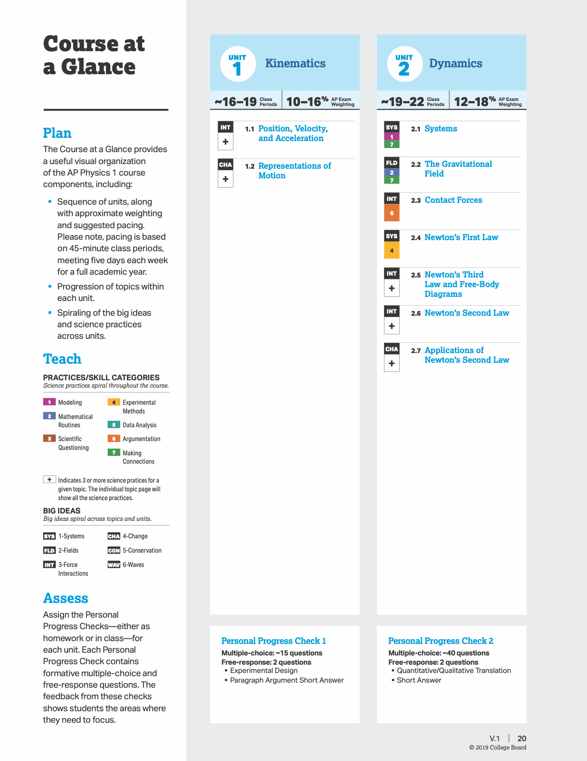

<https://apcentral.collegeboard.org/pdf/ap-physics-1-course-a-glance.pdf?course=ap-physics-1-algebra-based>

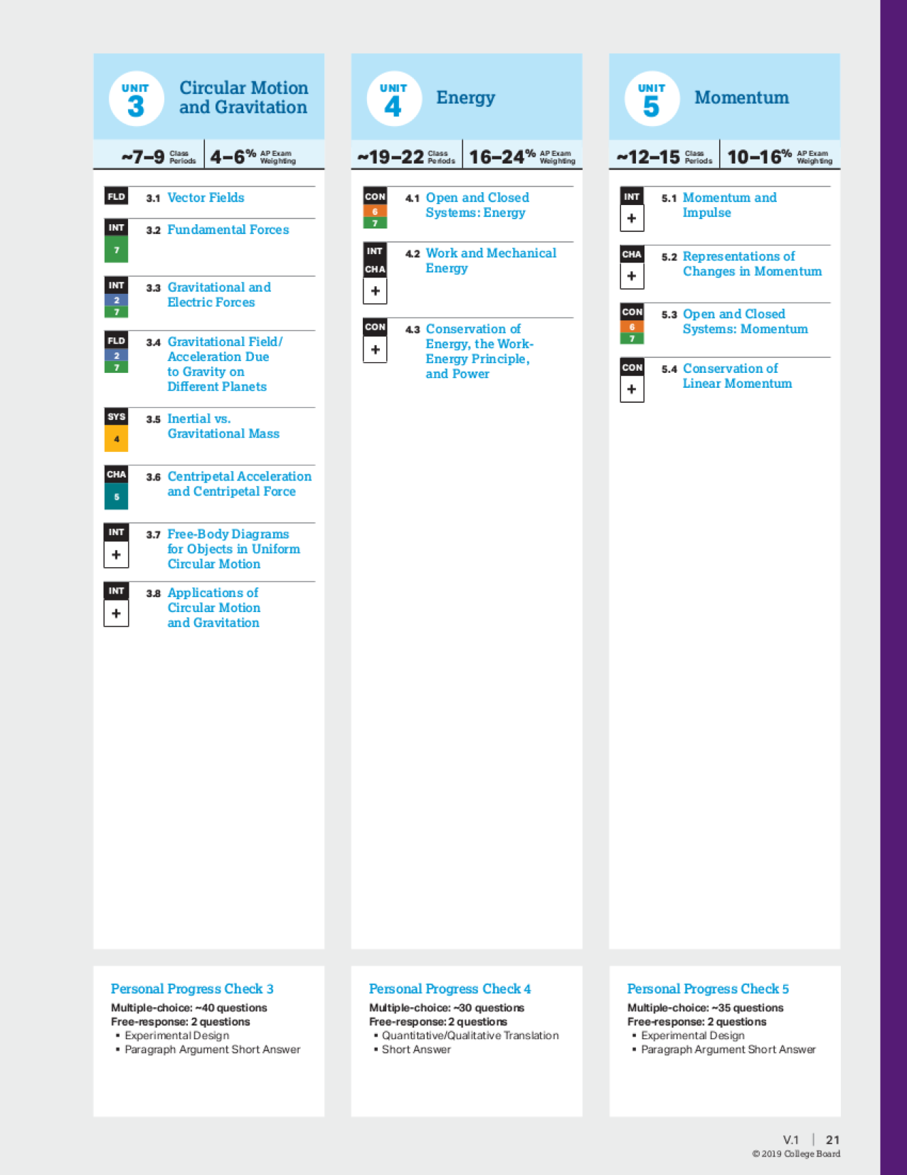

<https://apcentral.collegeboard.org/pdf/ap-physics-1-course-a-glance.pdf?course=ap-physics-1-algebra-based>

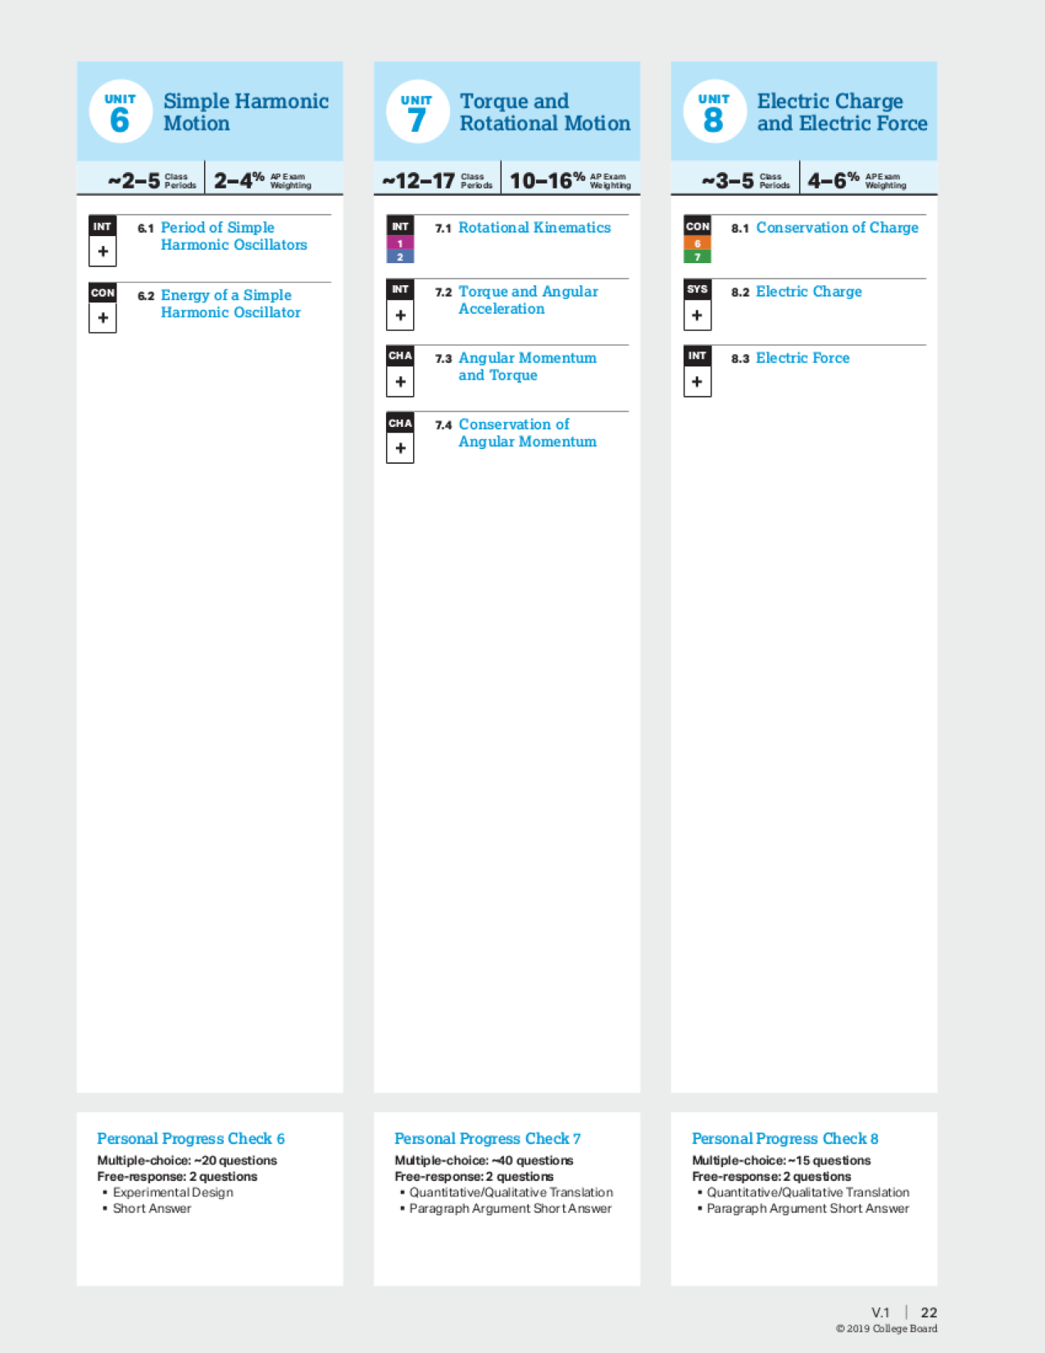

<https://apcentral.collegeboard.org/pdf/ap-physics-1-course-a-glance.pdf?course=ap-physics-1-algebra-based>

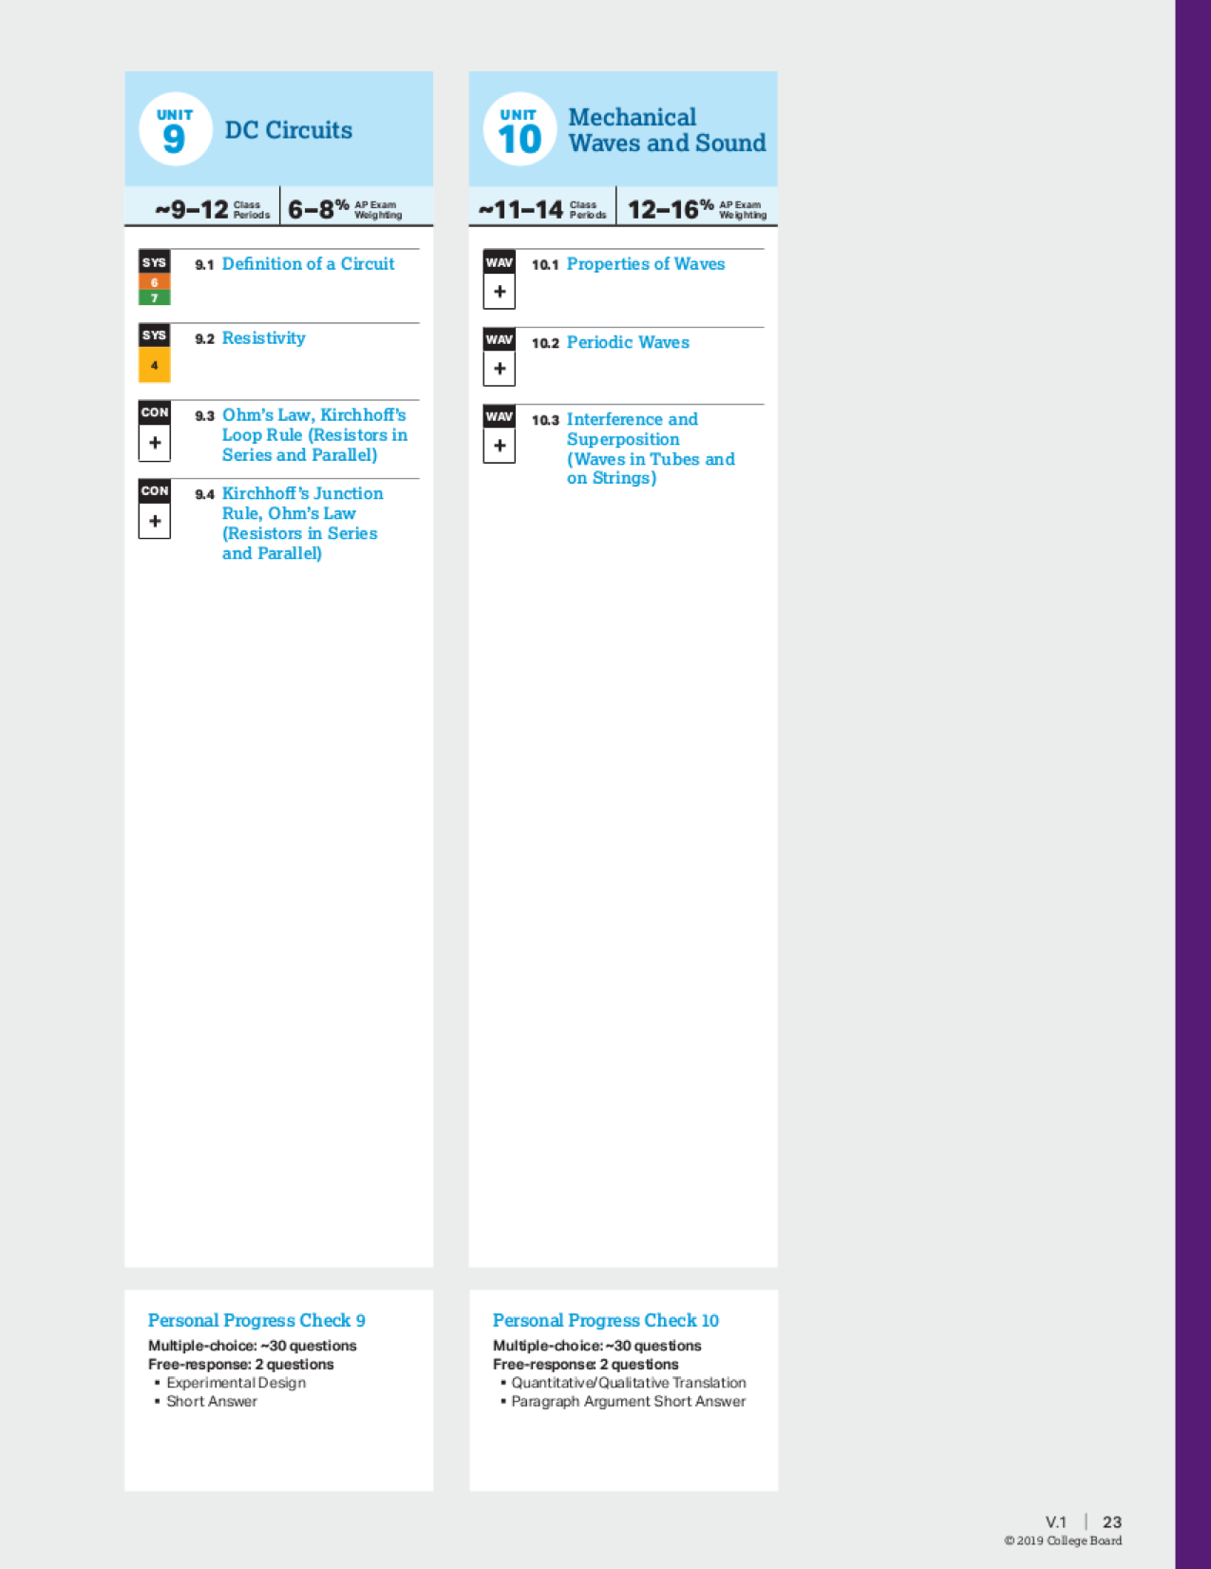

**MATERIALS**

Chromebook/Computer

Textbook and Lab Notebook/Composition book. If using a physical notebook, different colored pens/highlighters, colored pencils, etc. will provide better organization in your notes. There will be an option for a Digital Lab Notebook.

Scientific Calculator - see link below for calculators approved for the AP Exam

<https://apstudents.collegeboard.org/exam-policies-guidelines/calculator-policies>

**LAB**

Approximately 25-30% of your course work will be in the form of laboratory investigations.

If/When on campus, you will be required to wear appropriate safety attire while working in the lab.

A copy of the Laboratory Safety Rules will be given to you. You must earn a score of 85% on the Safety Test in order to be allowed to participate in any in-class laboratory experience. Safety will be reinforced in every laboratory experience. Anyone not observing safety regulations will be removed from the laboratory setting and earn a grade of “0” (zero) for the lab.

During distance learning, we will be utilizing online and web-based labs, such as Gizmos and PHeT simulations. We will also use labs that can be completed with materials from around the house.

Students will record evidence of their scientific investigations in a lab notebook, either in print or digital format.

**TESTS AND QUIZZES**

Quizzes will be given frequently at the start of the class period consisting of 3-5 questions. These are regarded as practice for working with the material.

Usually once a week there will be a short concept check quiz consisting of short answer and multiple-choice questions. These quizzes will count in your grade.

All unit tests will follow the AP format, and are given at the end of every unit. Each test will have several multiple-choice questions and free-response questions.

**RESEARCH AND PROJECTS**

The College Board requires that the students are provided with opportunities to apply their knowledge of AP Physics concepts to real-world questions or scenarios to help them become scientifically literate citizens. Students will design, test, and analyze the results of a project of their choosing. They will research and apply their conclusions to answer their hypotheses. These projects will be featured in the student’s digital portfolios used in Senior Exit Interviews.

**GRADING AND HOMEWORK:** The grade in this course is determined by student performance on laboratory work, homework, classwork, and quizzes/tests. A student’s final grade for the semester is determined by total points from the semester assignments and tests as well the final exam. The grading scale below will be used to determine your six week grades and semester grades:

**Grading Scale: Approximate Breakdown:**

A: 100% - 90% 60% - Unit Tests, Concept Quizzes, Final Exam

B: 89% - 80% 30% - Labs, Performance Assessments, and other Activites

C: 79% - 70% 10% - Homework/Classwork

D: 69% - 60%

F: Below 60 %

Students are given advanced notice of due dates for lab reports and homework assignments. Homework is assigned throughout the week and may consist of a reading assignment, a writing assignment, or both. Homework is meant to reinforce what is studied in class and to assist students in mastering the content standard—it should be taken seriously! It is the student's responsibility to turn in assignments when they are due. Late work will be accepted but may be subject to a reduction in points.

**MAKE-UP POLICY:** Students are expected to make up all tests, classwork, and labwork missed as a result of an excused absence from school. It is the responsibility of the student to find out what homework and class assignments were missed, to obtain assignment sheets if needed, and to turn in the work ASAP. All assignments will be linked on the Weekly Agenda found on Google Classroom.

Students who fail an exam will be allowed to make up the exam provided that they attend a science department tutoring session or other approved tutoring and/or complete the Exam Analysis.

**HOW PARENTS CAN HELP:**

Make sure students are completing homework and projects and study for tests.

Check students grades online regularly.

E-mail or leave a message for me if you have any questions or concerns.

The above requirements and expectations are designed to provide your child and all other students the excellent learning climate they deserve. I look forward to meeting you and working with you this year in order to provide the best education possible for your student.

Thank you!

Mr. Proctor

**I/we have read, understand, and will follow the course requirements and expectations for AP Physics 1.**

Print Student Name _____________________ Student Signature and Date _________________________

Parent/Guardian Signature and Date _______________________________________________________