**4-2.** For each tile pattern in problem 4-1, draw Figures 0, 4, and 5 on graph paper. If it helps, copy Figures 1, 2, and 3 onto your paper.

**4-3.** Make an *x* → *y* table for the rule *y* = *x*2 − 2*x*.

* 1. Plot and connect the points on a complete graph.
  2. Does your graph look like a full parabola? If not, add more points to your table and graph to complete the picture.

**4-4.** THE GAME SHOW

Susan had an incredible streak of good fortune as a guest on the exciting game show, “The Math Is Right.” She amassed winnings of $12,500, a sports car, two round-trip airline tickets, and five pieces of furniture.

In an amazing finish, Susan then landed on a “Double Your Prize” square and answered the corresponding math question correctly! She instantly became the show's biggest winner ever, earning twice the amounts of all her previous prizes.

A week later, $25,000, a sports car, four round-trip airline tickets, and five pieces of furniture arrived at her house. Susan felt cheated. What was wrong?

**4-5.** Write the equation represented by the diagram below.    
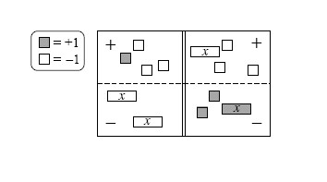

1. Simplify as much as possible and then solve for *x*.
   1. Check your solution.

**4-6.** Copy and simplify the following expressions by combining like terms.

* 1. *y* + 3*x* − 3 + 2*x*2 + 8*x* − 5*y*
  2. 2*x* + 4*x*2 − 6*x* 2 − 9 + 1 − *x* − 3*x*
  3. 2*y*2 + 30*y* − 3*y*2 + 4*y* − 14 − *y*
  4. −10 + 3*xy* − 3*xy* + *y*2 + 10 − *y*2

**4-7.** Use your pattern-finding techniques to fill in the missing entries for the table below. Then find a rule for the pattern.

|  |  |  |  |  |  |  |  |  |
| --- | --- | --- | --- | --- | --- | --- | --- | --- |
| IN (*x*) | 4 | 8 | 3 | −2 | −6 | 0 | 5 | 7 |
| OUT (*y*) | 17 | 65 | 10 | 5 |  | 1 | 26 |  |