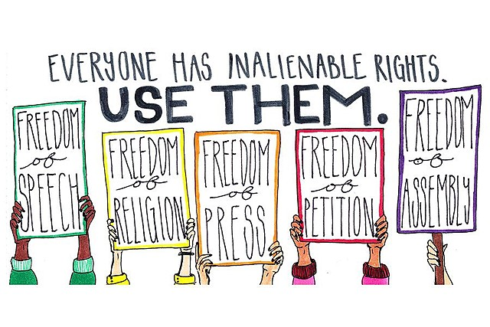
1st Amendment~guaranteed freedom of religion, speech, the press, assembly & petition
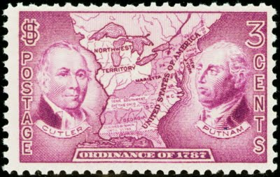
From: To:
_______________________________ _______________________________
_______________________________ _______________________________
_______________________________ _______________________________

Post Card Assignment For The 27 Amendments:
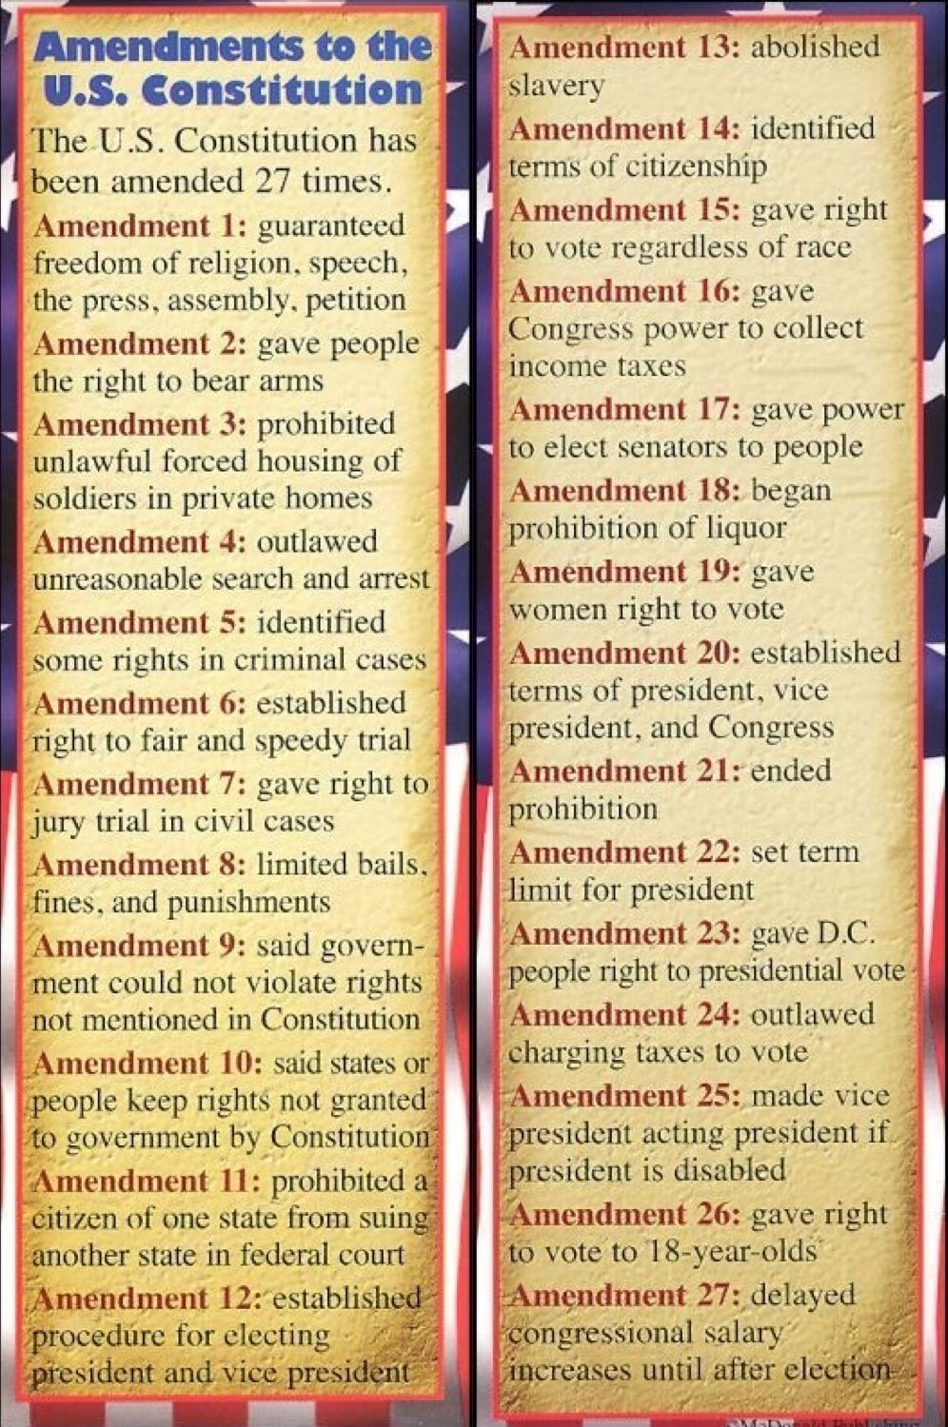
Your job is to create 27 post cards worth 10 points each (for a total of 270 points)
Each post card must have:
- a big picture, one that references the amendment you are working on~for example: #16 is about collecting taxes so your picture might have something to do with collecting taxes (1 point) ~see the other side of this handout
- have the amendment # (& what it says to the left) on it… (see what is written to the left of these bullets?? See how I wrote the same thing as Amendment 1 on the top of my picture on the other side??) You also need to work it in to the body of your paragraph somehow… (2 points)
- be “filled out correctly” (to & from names & addresses) (1point)
- have a stamp (1 point)
- make up a “scenario” for each post card that addresses the amendment you are writing about… for example: pretend that your friend is a huge Trump fan & you are glad he got banned from Twitter because of all the lies he told… the 1st Amendment gives you freedom of speech but it doesn’t let you lie…(2 points)
- ask/answer the question: Did the Founding Fathers go “far enough” or “too far” when they wrote the amendment? Aka, is the amendment well written the way it is or…(1 point)

- your opinion~is the amendment “relevant today” or does it need to be “tweaked” because it’s no longer relevant?? For example when the 2nd amendment was written, it took one minute to load a gun… maybe it needs to be amended again to ban assault weapons?? (2 points)
Do 2 Google Slides for each amendment (or you can use the post card paper that I have to print out each one.)
You should be able to do 2-3 amendments a day. So you have less than 2 weeks to get this assignment done….don’t procrastinate!!

