**OC Pathway Showcase held at the Marconi Automotive Museum in Tustin highlighted the CTE Programs in of our school schools,**

This event showcased the various pathways across Orange County that combine strong academics with real-life experiences that helps prepare students for future college and career success.

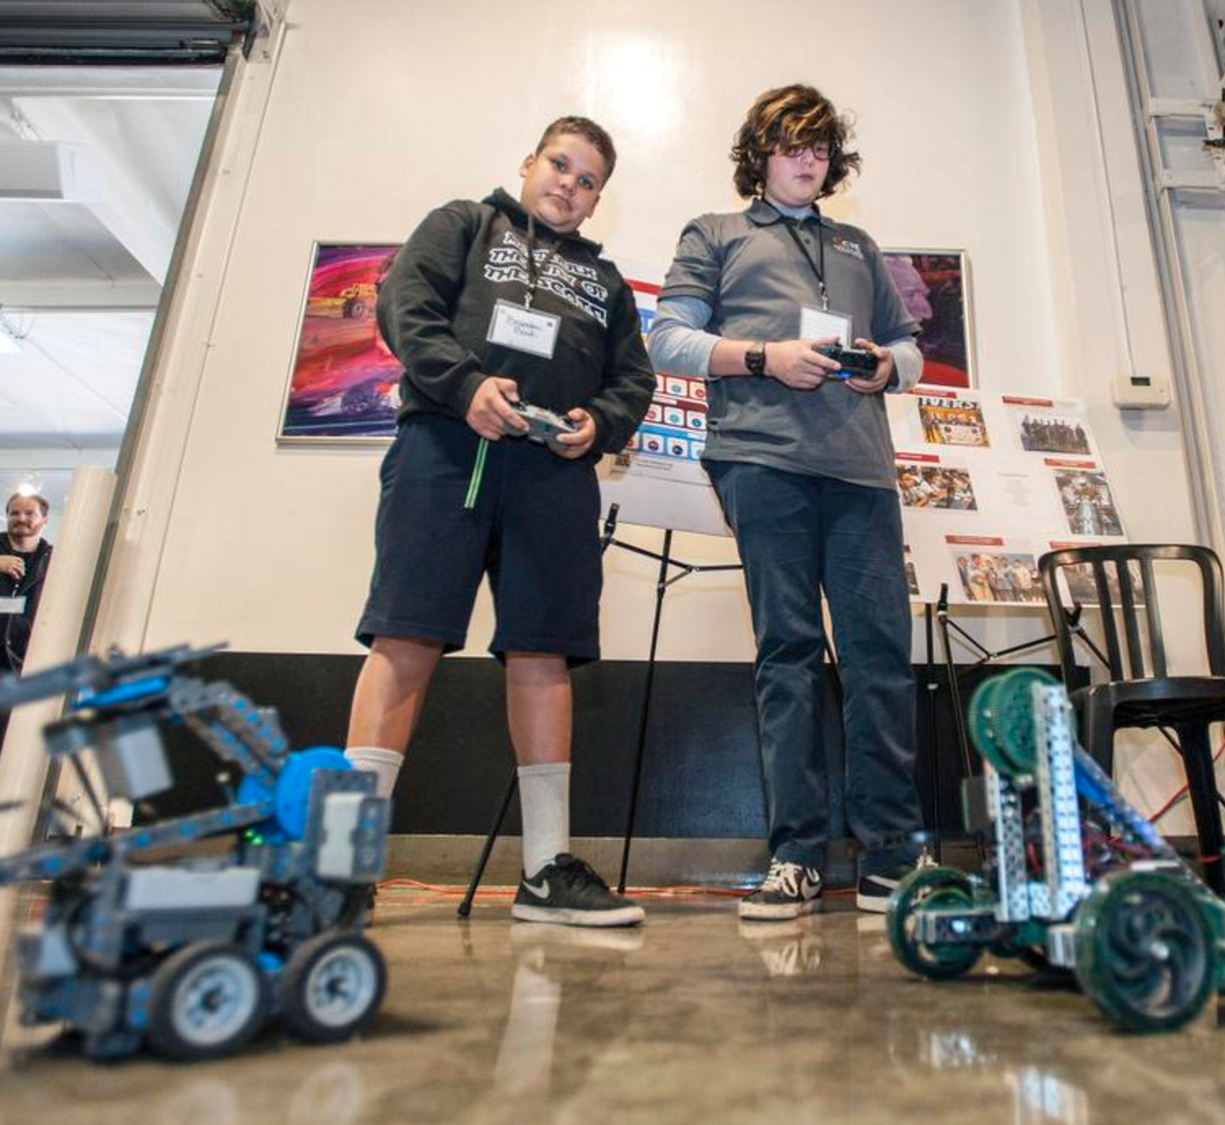

McFadden students, Brandon Bock and Jason Ayala at the Marconi Automotive Museum in Tustin, maneuver the VEX Robotic vehicles at the OC Pathway Showcase.

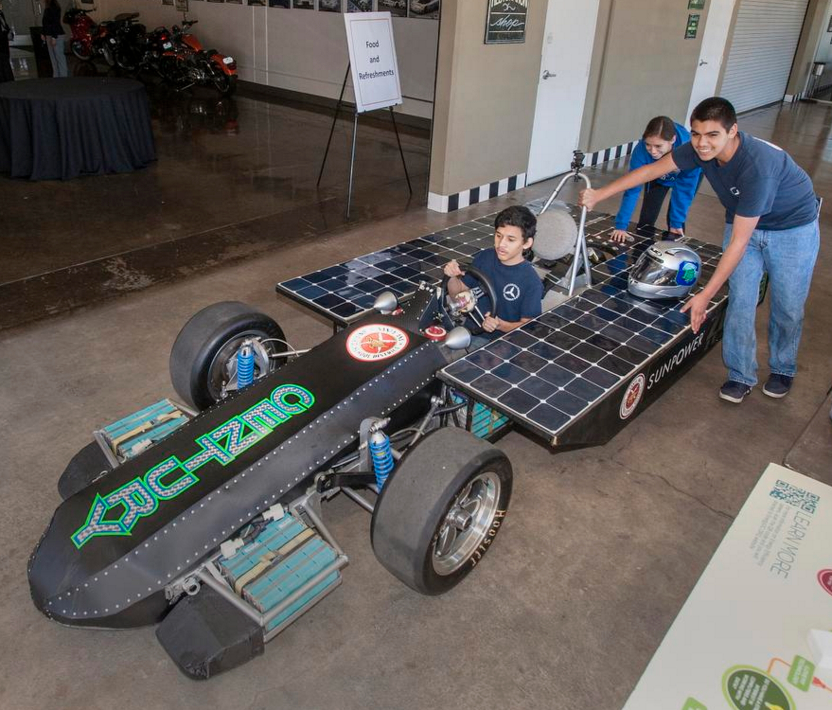

Students from Century High School, Lizbeth Gomez, Miguel Hernandez and Rudy Martin del Campo with Unstoppable 1 solar powered vehicle at the Marconi Automotive Museum in Tustin for the OC Pathway Showcase.

For more details about the event see the following article from the OC Register

<http://www.ocregister.com/articles/-736995--.html>