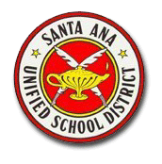
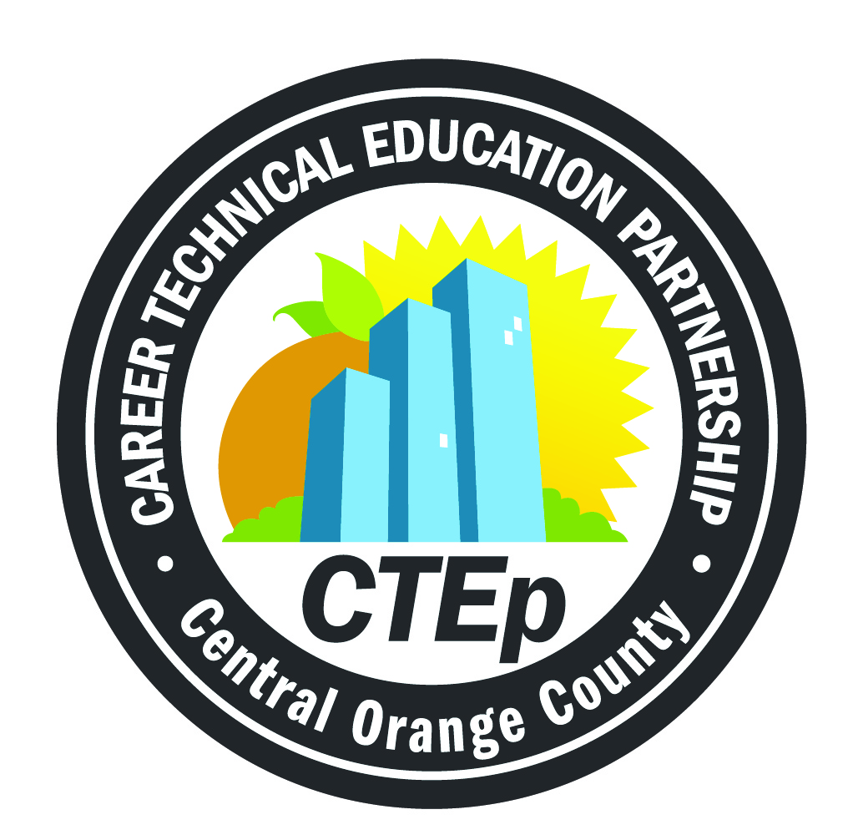
Career Technical Education
ANCHOR Standards
California State Board of Education

- Academics
Analyze and apply appropriate academic standards required for successful industry sector pathway completion leading to postsecondary education and employment. Refer to the industry sector alignment matrix for identification of standards.
- Communications
Language Standard: Acquire and accurately use general academic and domain-specific words and phrases sufficient for reading, writing, speaking, and listening at the (career and college) readiness level; demonstrate independence in gathering vocabulary knowledge when considering a word or phrase important to comprehension or expression.
- Career Planning & Management
Speaking and Listening Standard: Integrate multiple sources of information presented in diverse formats and media (e.g., visually, quantitatively, orally) in order to make informed decisions and solve problems, evaluating the credibility and accuracy of each source and noting any discrepancies among the data.
- Technology
Writing Standard: Use technology, including the Internet, to produce, publish, and update individual or shared writing products in response to ongoing feedback, including new arguments and information.
- Problem Solving & Critical Thinking
Writing Standard: Conduct short as well as more sustained research projects to answer a question (including a self-generated question) or solve a problem, narrow or broaden the inquiry when appropriate, and synthesize multiple sources on the subject, demonstrating understanding of the subject under investigation.

CTE ANCHOR Standards

- Health & Safety
Reading Standards for Science and Technical Subjects: Determine the meaning of symbols, key words, and other domain-specific words and phrases as they are used in a specific scientific or technical context.
- Responsibility & Flexibility
Speaking and Listening Standard: Initiate and participate effectively in a range of collaborative discussions (one-on-one, in groups, and teacher-led) with diverse partners, building on others’ ideas and expressing their own clearly and persuasively.
- Ethics & Legal Responsibilities
Speaking and Listening Standard: Respond thoughtfully to diverse perspectives; synthesize comments, claims, and evidence made on all sides of an issue; resolve contradictions when possible; and determine what additional information or research is required to deepen the investigation or complete the work.
- Leadership & Teamwork
Speaking and Listening Standard: Work with peers to promote civil, democratic discussions and decision making; set clear goals and deadlines; and establish individual roles as needed.
- Technical Knowledge & Skills
Writing Standard: Use technology, including the Internet, to produce, publish, and update individual or shared writing products in response to ongoing feedback, including new arguments or information.
- Demonstration & Application
Demonstrate and apply the knowledge and skills contained in the industry-sector anchor standards, pathway standards, and performance indicators in classroom, laboratory, and workplace settings, and the career technical student organization.

