Beowulf

Characteristics of an Epic Hero | Example from text – include the line numbers and page #  (Copy the quote exactly as it appears in the poem—no more than 4 lines)
1. Is significant and glorified

2. Is on a quest

3. Has superior or superhuman strength,
intelligence, and/or courage

4. Is ethical

5. Risks death for glory or for the greater
good of society

6. Is a strong and responsible leader

7. Performs brave deeds

8. Reflects the ideals of a particular society

Please complete this chart as a starting graphic organizer for your analysis of Beowulf as an epic hero. Find ONE quote that you could use to support each of these 8 characteristics. For EXTRA POINTS: Add two quotes for each characteristic. If you need extra space, attach another sheet of notebook paper.

Part 2: Is Grendel a Villain? Yes or No?

Directions: You will keep examples from the epic poem that prove Grendel is either a villain or he is not. You must choose only ONE opinion—meaning you have to show five examples of whether he is a villain OR he is not. You may not choose both!

Line Numbers | YES | NO

Part 3: Thoughtful Questions

- Do you think our society treats our soldiers and heroes as the Anglo-Saxon society treated their heroes? Why or Why not?

- Beowulf is the hero who battles the evil Grendel and Grendel’s mother. Yet, Beowulf dies when he fights the dragon. What do these events say about the battle between good and evil?

- Identify at least 3 kennings used in the poem. Then create your own original kenning.
Kenning #1: (Line #________)
Kenning #2: (Line #________)
Kenning #3: (Line #________)

My own original kenning:

Part 4: Three Different Battles

Directions: Using the Venn Diagram below, compare and contrast Beowulf’s battles with the three monsters (Grendel, Grendel’s Mother, and the Dragon). Consider how he fought, how he felt, the battle, the results, etc.
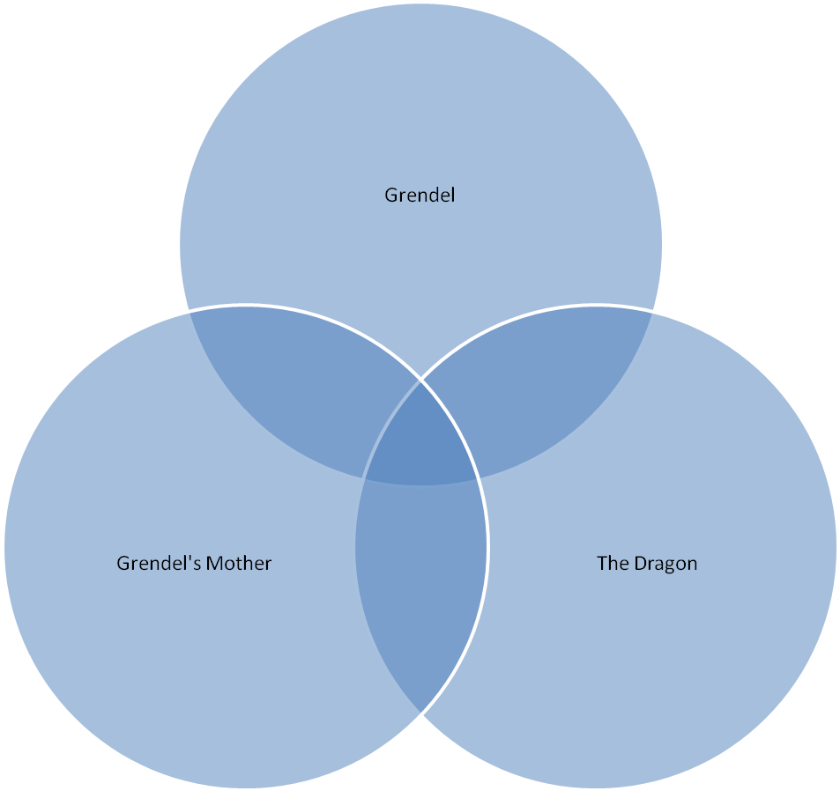

Part 5: An Epic Journey

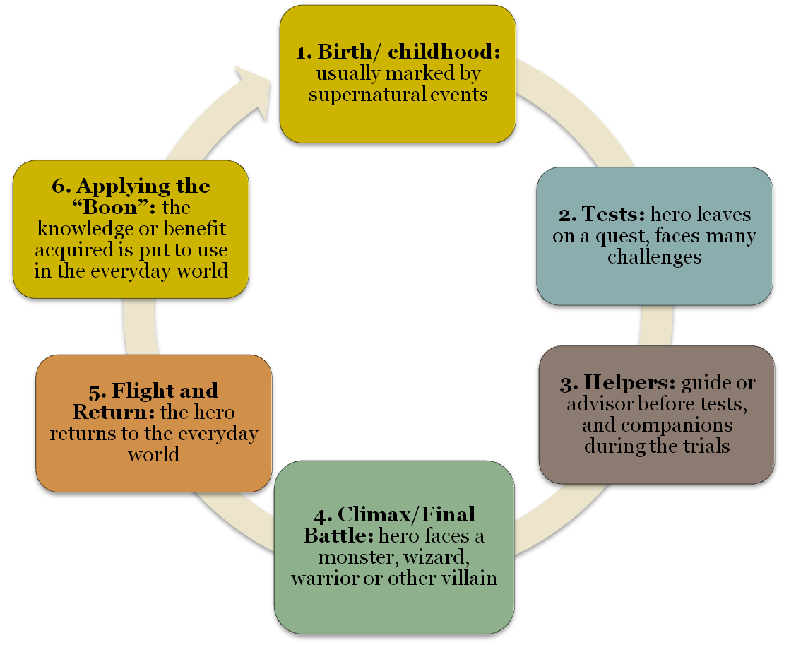

DIRECTIONS: Answer how each step of the Epic Journey Conventions are realized in Beowulf.

Step 1: Birth/Childhood (What background information do we know about Beowulf? Where did he come from? What was so special about him?):

Evidence from the text: Page #:___________, Line #:______________

Step 2: Tests (What tests/challenges did Beowulf have?)

Evidence from the text: Page #:___________, Line #:______________

Step 3: Helpers (Who helped Beowulf in each of his challenges?)

Evidence from the text: Page #:___________, Line #:______________

Step 4: Climax/Final Battle (What was Beowulf’s FINAL battle? How did his story end?)

Evidence from the text: Page #:___________, Line #:______________

Step 5: Flight and return (What are Beowulf’s final wishes? How do his wishes embody Anglo-Saxon beliefs about death?)

Evidence from the text: Page #:___________, Line #:______________

Step 6: Applying the “Boon” (How is Beowulf similar to modern day heroes? Choose one modern day hero to compare him to.)

