**The Odyssey**

Worksheet 1

*from* **Book 1**

**Tell the Story: pg. 651**

1. Who are the Muses?
2. Who is the “man skilled in all ways of contending”?
3. What happened to Odysseus’s men on the way home? (lines 10-15)
4. For how long has Odysseus been away from home?
5. Who kept him prisoner?
6. What does Athena beg her father to do? Who is her father?
7. What God is Odysseus’s enemy?
8. Who is sent to deliver the message from Zeus to free Odysseus?
9. What is Odysseus’s son name, and where does he live?
10. Who is speaking at the opening of the epic?

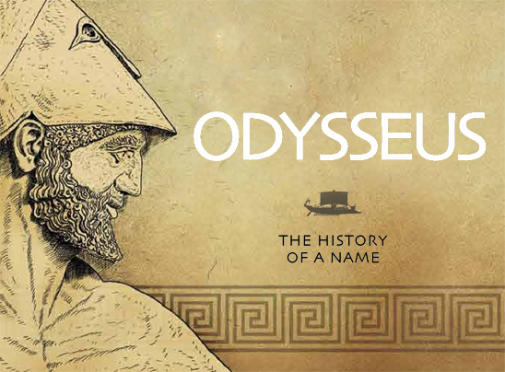

Part One: The Wanderings

Worksheet 1



Books 1-4

**Calypso, the Sweet Nymph: pg. 652-654**

1. What is the name of the messenger God? What does is he to tell Calypso?
2. Where does Calypso live? Describe with two examples of imagery.
3. What does Calypso promise Odysseus?
4. How did Odysseus behave during the day?
5. What distinguishes humans from Gods?
6. According to Odysseus, how does Calypso compare to his wife?
7. Where does Odysseus want to sail? Who makes it difficult for him?
8. What happens to Odysseus’s raft?
9. Where does Odysseus land?
10. What does Odysseus do one he lands?

**“I AM LAERTES’S SON…”**

Worksheet 2

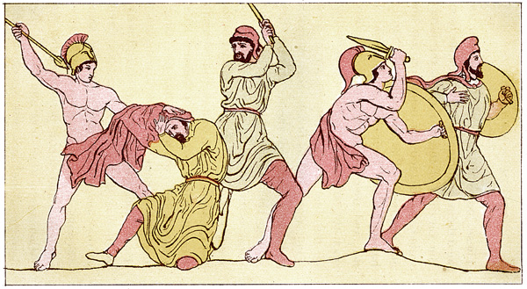

**Book 6-8 Pg. 656-658**

1. Who orders a banquet to honor the stranger guest, Odysseus?
2. What is Odysseus’s father’s name? Where is his home?
3. What story does Odysseus as the minstrel to tell him?
4. Describe some of the events that took place in Cicones.
5. Why did Cicones defeat Odysseus and his men?
6. How many men does he loose?

**The Lotus Eaters: page 658**

1. After Odysseus and his men drifted aimlessly for nine days, where do they land?



1. What feeling do the Lotus plants produce in those who ingest them?
2. How many men did Odysseus send to check out the Lotus eaters?
3. What does Odysseus do to the men to prevent them from eating Lotus?
4. Odysseus is the _______________________of the ancient Greek heroes.

**The Cyclops: page 660-670**

1. What is the Cyclops’s name with whom Odysseus has a conflict?

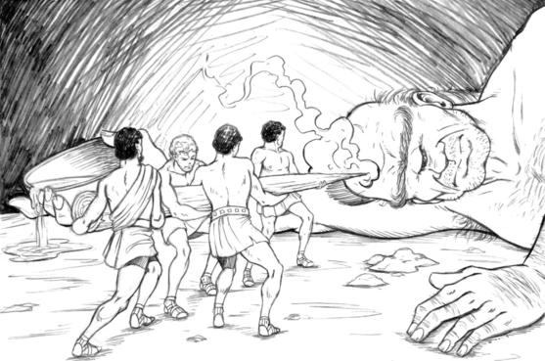

1. Who is the father of this Cyclops?
2. Where did the men wait for the Cyclops to return?
3. What did the Cyclops put at the entrance of the cave?
4. What does the Cyclops ask the men?
5. What does Odysseus tell the Cyclops?
6. How does the Cyclops respond to Odysseus who tells him to listen to Zeus?
7. What does Odysseus say happened to their ship?
8. What does the Cyclops do to two of his men?
9. What does Odysseus make out of a wooden club? What does he plan to do with it?

Worksheet 2

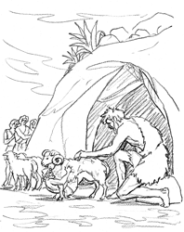

1. What did Odysseus do to his men so they could escape the cave?
2. What did the men take to their boat?
3. What did Odysseus yell to the Cyclops once they were on the boat?
4. What do the men warn Odysseus not to do?
5. What request does the Cyclops make to his father?

**The Bag of Winds and the Witch Circe: page 673-674**

1. What is the name of the island where then men land next?
2. Who is Aeolus, and what does he do?
3. What do the sailors do to the bag of winds? What happens?
4. Who are the Laestrygonians, and what do they do?
5. Where do the men land next, and who lives there?
6. Who leads the party of 22 men to explore the island?
7. What creatures surround Circe?
8. What was to goddess Circe doing while the men found her?
9. Who is Polites?
10. Which man does not go inside Circe’s home? Why?
11. What does did Circe add to the men’s drink? What happens to the men?
12. What does Hermes give Odysseus?
13. What does Circe persuade Odysseus to do? For how long does Odysseus stay with Circe?
14. Where do Odysseus and the men have to do before heading home?

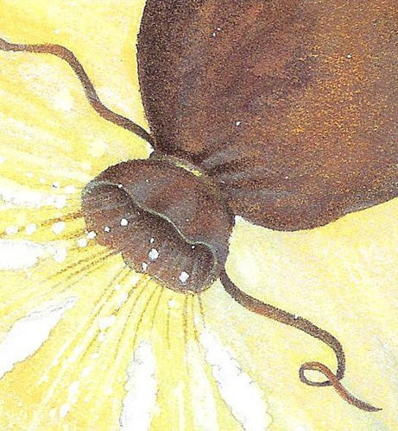

1. Who will share a prophecy with Odysseus?

**Land of the Dead: page 675-677**

Worksheet 3

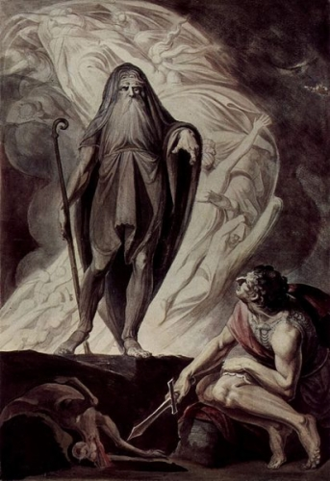

1. Where does Odysseus go next?
2. Who is the blind prophet?
3. What does Odysseus sacrifice to the dead?
4. What does Odysseus sacrifice to Teiresias?
5. Who were some of the dead?
6. According to Teiresias, who will cause Odysseus trouble? Why?
7. What will Odysseus find in Thrinakia?
8. What will happen if Odysseus’s crew eats the cows?
9. How many survivors will remain?
10. What does Teiresias say Odysseus will find when he returns home?
11. Whose ghost does Odysseus see? How did she die?
12. What are the people’s “bodies” like in the Underworld?
13. After the Land of the Dead, where does Odysseus go?

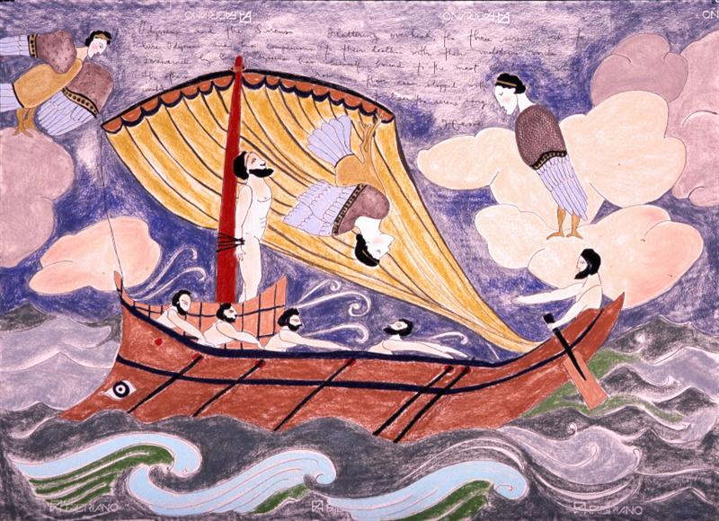

**The Sirens, Scylla and Charybdis: page 678-683**

1. What is the first danger about which Circe warns Odysseus?
2. Describe Sirens.
3. What will happen to Odysseus if he hears the sirens sing?
4. What does Circe tell Odysseus to do to the men’s ears?
5. If Odysseus wants to listen to the sirens, what can he do?
6. What is the second danger?
7. Describe Scylla.
8. How many men does Scylla eat from passing ships?
9. What is the third danger?

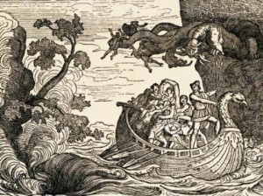

1. What does Charybdis do three times a day?

Worksheet 3

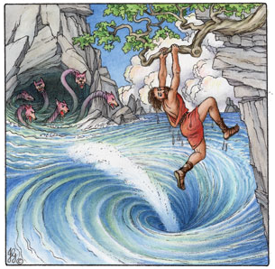

1. What advice does Circe offer?
2. After going past Scylla, where will they go? What is on that island?
3. What does Odysseus NOT reveal to his crew?

**The Cattle of the Sun God: page 684-686**

1. If Odysseus’s crew eats the beeves (cattle), what will happen?
2. What do the men eat that belongs to Helios?
3. Who punishes the men?
4. How are the men punished?
5. Where does Odysseus go? (Which is were we meet him)

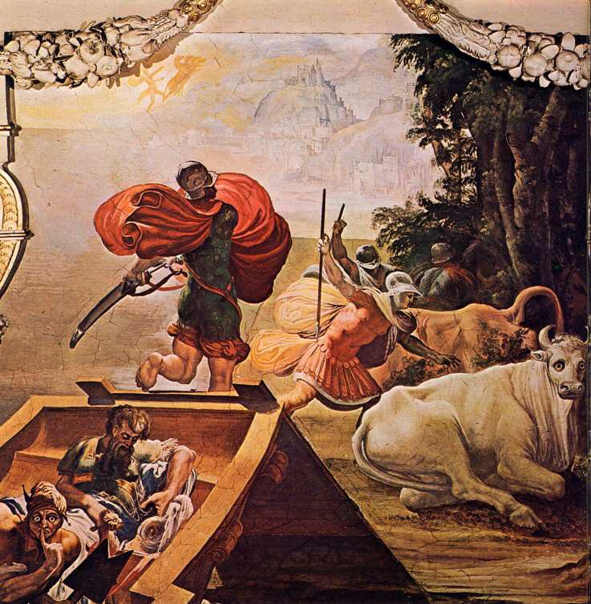

**End of Part One**

Part Two: Coming Home

Worksheet 4

**Coming Home: page 690**

1. In Book 13, where does Odysseus secretly go?
2. How does Athena disguise Odysseus?
3. Whose house does Odysseus go to in Book 14?
4. In book 15, where is Telemachus?
5. Where does Athena advise Telemachus to go?
6. What does she warn Telemachus about?

**The Meeting of Father and Son: page 691-694**

1. Who is in the hut?
2. Who appears at the door to the hut?
3. How does Eumaeus react to this appearance?
4. Why does Telemachus go to see Eumaeus before he goes to see anyone else?
5. What does Eumaeus say about Penelope?
6. Who does Telemachus think is the third person in the hut?
7. What does Telemachus tell his father, disguised as a beggar, he will do for him?
8. What would happen to the “beggar” if he were to stay in the palace?
9. What does Eumaeus tell Penelope?

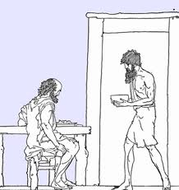

1. What does Athena do for the beggar?
2. How does Telemachus react to this transformation?
3. How do father and son react to one another’s presence?

**The Beggar and the Faithful Dog: 694-695**

Worksheet 4

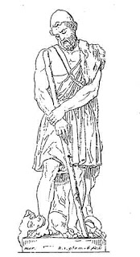

1. How do Eurycleia and Penelope react to Telemachu’s return?
2. What did the soothsayer (fortune-teller) inform Penelope?
3. Who is Odysseus disguised as on his return home?
4. What is the name of Odysseus’s old dog?
5. How old is the dog?
6. Where was the dog lying when Odysseus found him?
7. What does the dog do when he recognizes Odysseus? What happens after he sees him?
8. What do the suitors do to the beggar?
9. Why is Penelope supportive of the beggar?
10. What does Penelope say to Telemachus in Book 18?

**The Epic Continues: page 696**

1. What is the problem with the maids?
2. What does Penelope ask Odysseus, the beggar in disguise?
3. What does Odysseus request that Penelope not ask him about?
4. What would make Penelope happy?
5. What does Penelope tell Odysseus about the suitors?
6. How does Penelope feel about marrying one of the suitors?
7. What does the beggar tell Penelope about Odysseus?
8. What does Eurycleia say to Odysseus?
9. How does Odysseus respond to Eurycleia?
10. What did Eurycleia recognize on Odysseus’s thigh?
11. What secret must Eurycleia keep?
12. Explain the spell Athena cast on Penelope?

Worksheet 5

**The Test of the Great Bow: page698-699**

1. What does Penelope take out of the storage room?

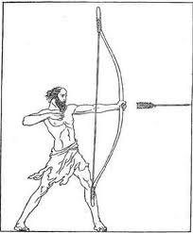

1. What is the prize for the suitor who wins the contest?
2. Explain the test the suitors must pass in order to win the test?
3. Who does Odysseus, the beggar, talk to outside?
4. What does Odysseus, the beggar, reveal about his identity?
5. What orders does Odysseus give to Eumaeus and Philoteus?
6. Who allows Odysseus the test of the great bow?
7. What does Odysseus tell Eumaeus to do with Penelope and the maids?
8. What did Odysseus tell Telemachus to do with the suitor’s weapons?
9. Who stands next to Odysseus as a sign of his willingness to help him defeat the suitors?

**Death at the Palace: page703-705**

1. How many suitors must Odysseus kill?
2. Who is Antinous? Why doesn’t Odysseus like him?
3. What are the reasons Odysseus provides for killing the suitors?
4. What deal does Eurymachus try to make with Odysseus?
5. What goddess shows up to help?
6. What order does Odysseus give the maids? What does he do to them?

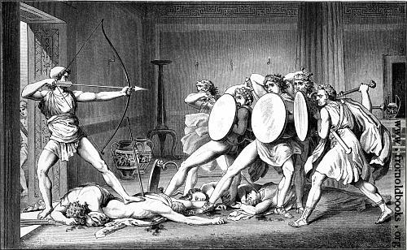

**Odysseus and Penelope: page706-709**

Worksheet 5

1. Why does Penelope feel the need to test her husband?
2. What cruel comments does Telemachus make to his mother?
3. How does Penelope respond to Telemachus?
4. How does Odysseus appear after his bath?
5. Where does Penelope tell Eurycleia to put the marriage bed?
6. Why does Odysseus become upset when Penelope makes her request?
7. What was one of the legs of the bed made out of?
8. What was built around the bed?
9. What would someone had to have done in order to move the bed?
10. How do Odysseus and Penelope act toward one another at the end?