Santa Ana Unified School District
1601 E. Chestnut Avenue
Santa Ana, California 92701

MINUTES

REGULAR MEETING
SANTA ANA BOARD OF EDUCATION

September 28, 2004

CALL TO ORDER

The meeting was called to order at 5:00 p.m. by Board President Richardson. Other members in attendance were Dr. Yamagata-Noji and Mr. Palacio. Mr. Tinajero and Mrs. Avila arrived at 5:15 p.m.

Cabinet members present were Dr. Bennett, Dr. Stabler, Mr. Sharp, Dr. Stainer, Dr. Bratcher, and Mrs. Araujo-Cook.

MEETING RECESSED AND RECONVENED

At 5:00 p.m., the Regular meeting was recessed to Closed Session to consider real estate negotiations, legal matters, personnel matters, special education contracts, and student discipline issues.

The Regular meeting was reconvened at 6:25 p.m.

There were approximately 75 members of the community and District staff in the audience.

PLEDGE OF ALLEGIANCE

The meeting was opened with the Pledge of Allegiance led by Mr. Palacio.

REPORT OF ACTION TAKEN IN CLOSED SESSION

By a vote of 3-0, the Board took action to ratify costs incurred related to a settlement agreement for the 2003-04 school year.

By a vote of 3-0, the Board took action to ratify a nonpublic school contract and individual service agreement for the education of disabled pupils between the SAUSD and TEC for the 2003-04 school year.

By a vote of 3-0, the Board took action to approve a nonpublic school contract and individual service agreement for the education of a disabled pupil between the SAUSD and Mardan School for the 2004-05 school year.

By a vote of 3-0, the Board took action to ratify a nonpublic school contract and an individual service agreement for the education of disabled pupils between the SAUSD and Rossier Park School for the 2004-05 school year.

By a vote of 3-0, the Board took action to ratify a master contract and individual service agreement with nonpublic schools for the education of disabled pupils between the SAUSD and TEC for the 2004-05 school year.

By a vote of 3-0, the Board took action to ratify to continue an individual service agreement with a nonpublic school for the education of a disabled pupil between the SAUSD and TEC for the 2004-05 school year.

By a vote of 3-0, the Board took action to ratify to continue a master contract and an individual service agreement with a nonpublic agency for the education of a disabled pupil between the SAUSD and Speech Pathology Associates for the 2004-05 school year.

By a vote of 3-0, the Board took action to continue a master contract and an individual service agreement with a nonpublic agency for the education of a disabled pupil between the SAUSD and Prentice School for the 2004-05 school year.

By a vote of 3-0, the Board took action to ratify an individual service agreement with a nonpublic agency for the education of a disabled pupil between the SAUSD and Pacific Child & Family Associates for the 2004-05 school year.

By a vote of 3-0, the Board took action to ratify a master contract and an individual service agreement with a nonpublic agency for the education of a disabled pupil between the SAUSD and Behavioral & Educational Support Team for the 2004-05 school year.

By a vote of 4-0, the Board took action to terminate a classified employee as named in Closed Session.

By a vote of 4-0, the Board took action to approve the appointment of Art Jimenez to the position of Assistant Principal at Walker Elementary School.

By a vote of 4-0, the Board took action to approve the appointment of William Souza to the position of Assistant Principal at Madison Elementary School.

By a vote of 4-0, the Board took action to approve the appointment of Maricela Roque to the position of Assistant Principal at Diamond Elementary School.

SUPERINTENDENT'S REPORT

Attention was directed to the beautiful artwork posted in the Board room. Santa Ana High School shared talents through a variety of mediums in an impressive and compelling exhibit and on the opposite wall Spurgeon Intermediate artists thinking “outside the box,” used positive and negative space shapes and color to apply California learning standards to art.

Dr. Mijares introduced SAUSD’s newest Administrators. Mr. Juan Lopez, Assistant Superintendent, Human Resources and Mr. Don Trigg, Associate Superintendent, Business Services. He then briefly described the backgrounds of each. The gentlemen were welcomed and congratulated by the Board of Education.

The Superintendent then called upon Ms. Jamie Brown, Director of Purchasing who was present in the audience. The Board welcomed and congratulated Ms. Brown to the Santa Ana Unified School District.

Dr. Mijares recognized Mr. Rueben Martinez, owner of Liberia Martinez Books and Art Gallery in Santa. Mr. Martinez was recently selected to receive the MacArthur Fellows Program Award in the amount of $500,000. The recipients may use their awards without restrictions. Dr. Mijares said that Rueben is the most deserving person. Rueben has supported education in public schools through word, act, and deed. He helped create Santa Ana’s Reading City Project. He has given away as many books as he has sold. He encourages young authors and artists. He has passed on his passion to the children of Santa Ana. Mr. Martinez’ work has been recognized and appreciated locally, and now, worldwide. Dr. Mijares presented the Superintendent’s BRAVO! Award for Rueben’s genuine support and service to the community and children of Santa Ana. The Superintendent read an email from a mutual friend, “I have been in awe of your relentless efforts to promote literacy and the love of reading to young and old. However, it is your commitment to social justice that touches me the most. You are a true role model. You personify the American Dream.” The Board, audience, and the Superintendent thanked and congratulated Mr. Martinez. Board members also expressed their appreciation for Mr. Martinez’ contributions to the children of Santa Ana.

Presented on a video clip was George W. Bush, President of the United States welcoming the Mendez family, who were present at the White House as guests. He said that the family fought discrimination and gained victory. Hispanic Heritage Month was also celebrated at many schools throughout the SAUSD. Wilson elementary held a festival. Children dressed in costumes and performed regional dances. Kennedy elementary celebrated their very first arts festival with many educational activities. Spurgeon intermediate celebrated in the classrooms with lesion plans celebrating the special month.

Dr. Mijares also announced that the construction tour of Manuel Esqueda Elementary, Segerstrom High School, and Godinez Fundamental High School was enlightening. The Board received up-to-date information on the progress of those new schools.

In addition, the video clip highlighted the Rebuilding Together Day at Spurgeon Intermediate on Saturday, September 18th. Over 200 volunteers, that included school staff, parents, students, and staff from three local Wal-Mart Stores made improvements to the school plant. Mr. Steve Carpenter coordinated the efforts with the SAUSD’s Maintenance Department, CSEA, Human Resources, and the Public Information Office, as well as the Principal, Dr. Robert Laxton. The Superintendent then called upon Mr. Steve Carpenter, who was present in the audience. Mr. Carpenter was recognized for his coordination efforts and contributions displayed during the Rebuilding Together Day at Spurgeon Intermediate. Dr. Mijares presented a beautifully framed photo taken on that special day. The photo included the Superintendent and Board members with Mr. Carpenter. The Superintendent and Board commended Mr. Carpenter for his deeds and spirit of volunteerism.

All elementary school students and their parents are invited to participate in the District’s first annual Health and Safety Fair on Saturday, October 23, from 10:30 a.m. to 2:30 p.m., at the District Office in the School Police Services parking lot. The District School Police and the PTA will sponsor the fair. There will be free vision and health screenings, children’s fingerprinting, free school supplies, free promotional items, beverages and much more. Elementary school age kids will be eligible to submit an entry to name the new Santa Ana Unified Police Dog. The grand prize is a bike and safety helmet!

Dr. Mijares congratulated the Teacher Education Academy at Century High School, also known as TEACH. The group, headed by project director Janice Hopper, was awarded another Vanguard University scholarship, which will be offered to a 2004-2005 TEACH Academy graduate. This is the fifth full-ride, four-year scholarship given to the Century program. Four Academy graduates are currently attending Vanguard University.

The Superintendent announced that the new issue of Above the Mean & Beyond, a special public safety issue has been distributed to school sites. He encouraged the community to read a copy or to obtain a copy from your local school.
He encouraged students to attend the Youth Expo 2004, to be held on Saturday, October 2, at the Santa Ana College campus. He urged all students in grades 6 through 12 and their parents to attend this great educational, informational event. The Expo runs from 10:00 a.m. to 2:00 p.m.

Dr. Mijares invited the community to attend the Santa Ana Council PTA’s Meet the Candidates Forum. The event will host all of the candidates running for election to the Santa Ana Unified Board of Trustees will be held on Thursday, September 30, from 7:00 p.m. - 9:00 p.m. in the Century High School auditorium.

The Superintendent announced that a Parent Conference is scheduled at Century High School on October 16, 2004, beginning at 9:00 a.m. Various workshops will be available, designed for parents to help their children.

PUBLIC HEARING

Ms. Brown stated that the SAUSD must provide a public hearing to continue with the proceedings for the formation of the Community Facilities District.

Mr. Richardson then announced that the public hearing was previously noticed regarding the proposed formation of Community Facilities District (CDF) No. 2004-1 of the SAUSD, and related matters. He said that a report regarding the community facilities district was prepared by David Taussig & Associates describing Community District No. 2004-1. Ms. Brown was asked to describe the matters currently before the Board of Education.

Ms. Brown briefly provided an overview of the CFD, facilities and special taxes. She stated that representatives of Stradling Yocca Carlson & Rauth and David Taussig & Associates were available to answer any questions.

Mr. Richardson formally opened the public hearing regarding the CFD, levy of a special tax, issuance of bonds, and the provision of a certain School District water and sewer facilities. He asked those present who wished to speak in favor of, or in opposition to these matters to step to the podium. He then asked the members of the Board if they wished to speak on the matters. They responded negatively. He then proceeded. Having received no protests to any of the matters addressed in this public hearing, he declared the public hearing closed.

Mr. Richardson asked that all items pertaining to the CFD be presented accordingly:

Mr. Richardson continued. He stated inasmuch as these proposed actions have not been precluded by a majority protest, he would entertain a motion to approve Resolution No. 04/05–2580 - establishing Community Facilities District No. 2004-1 of the Santa Ana Unified School District and approving related actions

It was moved by Mr. Tinajero, seconded by Mrs. Avila, and carried 5-0, to adopt Resolution No. 04/05-2580 – resolution of the SAUSD Board of Education establishing Community Facilities District (CFD) No. 2004-1 (Central Park Project) and approving the forms of Joint Community Facilities Agreement and Mitigation Agreement.

It was moved by Dr. Yamagata-Noji, seconded by Mr. Tinajero, and carried 5-0, to adopt Resolution No. 04/05-2581 – resolution of the SAUSD Board of Education acting as the legislative body of CFD No. 2004-1 (Central Park Project) determining the necessity to incur bonded indebtedness in an amount not to exceed $16,000,000 within Community Facilities District (CFD) No. 2004-1 and calling an election thereon.

Mr. Richardson then asked Mr. Tinajero, Clerk of the Board if he has conducted the election for Community Facilities District No. 2004-1.

Mr. Tinajero responded affirmatively. The results of the election for propositions A and B are 43 votes in favor and zero votes opposed. He stated that all measures have passed by at least two-thirds of the votes cast.

Mr. Richardson called for a motion to approve Resolution No. 04/05-2582 – declaring the results of the election.

It was moved by Dr. Yamagata-Noji, seconded by Mr. Tinajero, and carried 5-0, to adopt Resolution 04/05-2582 – resolution of the SAUSD Board of Education acting in its capacity as the legislative body of community Facilities District (CFD) certifying the results of the September 28, 2004, special tax and bond election.

The President then referred to the first reading of the Ordinance which would assess special taxes in CFD No. 2004-1. He called for a motion to waive reading of the entire text of the Ordinance.

The Board unanimously approved to waive reading the entire text of the ordinance.

Mr. Richardson asked Mr. Tinajero, Clerk of the Board to read the full title of the Ordinance. Mr. Tinajero responded in reading the ordinance.

Ordinance of the Board of Education of the SAUSD authorizing the levy of a special tax within CFD No. 2004-1 (Central Park Project) of the SAUSD.

Mr. Richardson announced that the proceedings for the formation of CFD No. 2004-1 has concluded.

APPROVAL OF MINUTES

It was moved by Mrs. Avila, seconded by Dr. Yamagata-Noji, and carried 5-0, to approve the Minutes of the Regular Board meeting of September 14, 2004.

PRESENTATION - 2004 Student Achievement Data

Dr. Mijares introduced the item. He stated that the information is very detailed and consuming. He stated that a special study session would be scheduled to provide the time and attention that is needed to bring forward all the information in respect to student achievement data.

Dr. Stainer stated that the following information is an overview of the 2004 STAR Results, State Academic Performance Index (API) results, the federal Adequate Yearly Progress Report (AYP) and achievement trends. She said that all public school students in California are required to take the STAR assessments for their grade level. Students in grades 2-8 are tested in reading, language, spelling, and mathematics. Students in grades 8-11 take the mathematics test for the course for which they have been enrolled. Students in 9-11 are assessed by course exams in all core subjects. All students in grades 4 & 7 take a state writing assessment in addition to the English language arts standards tests. The results of the STAR tests along with other measures are the basis for the state Academic Performance Index (API) and federal Adequate Yearly Progress (AYP) accountability reports.

She and Dr. Bratcher then presented the following Overview:

STAR Achievement & Accountability highlights:

- There continue to be gains on STAR at the elementary level.
- For the first time in the 6-year history of the California Standards Tests, some of the largest gains are at the secondary school levels.

Contributing Factors of School Performance Gains:
- Increases in the number of students scoring in the proficient and advanced levels
- More students moving out of the Far Below Basic and Below Basic levels
- 53% of the Class of 2006 passing both sections on the CAHSEE on the first try.
- Increases in passing rates on the CAHSEE in both ELA and Math
- More English Learners reaching higher performance levels in English language development and beginning to close the achievement gap on the state standards tests
Resulting Performance Indicators:
- The District gained 10 points, taking its API to a new high of 624
- SAT scores went up this year in both Math and Verbal sections
- The district reached 32 out of 34 state AYP accountability targets

Average National Percentile Ranks – CAT/6
Grade | Reading 2003 | Reading 2004 | Math  2003 | Math  2004
2 | 27 | 28 | 41 | 42
3 | 24 | 24 | 41 | 43
4 | 24 | 25 | 40 | 40
5 | 29 | 30 | 35 | 37
6 | 29 | 27 | 34 | 34
7 | 30 | 31 | 34 | 34
8 | 30 | 31 | 38 | 38
9 | 24 | 29 | 33 | 36
10 | 29 | 30 | 37 | 39
11 | 33 | 35 | 37 | 36

California ELA Standards Tests 2004 Elementary Comparisons

state and Federal Accountability:
- Academic Performance Index (API) State System for schools and districts. Growth Model
- Adequate Yearly Progress (AYP) Federal NCLB accountability for schools and districts. Absolute Model
- Title III federal Annual Measurable Achievement Objectives (AMAOs) have been set for percents of EL students reaching proficiency in English.

Adequate Yearly Progress toward No Child Left Behind Accountability Targets

Target for  Percent Proficient  12.0 % | Participation Rate  95% |  | Additional Indicator  API>560 | Minimum Graduation Rate  82.4 | Targets Met
NO  (all but one subgroup – Students  with Disabilities) |  | YES | YES | YES | 32 out  of 34

API components-Growth Model State Target 800
1999-2001 | SAT/9
2002 | SAT/9 and CST
2003 | CAT/6,CST,CAHSEE
2004 | CAT/6,CST, CAHSEE, CAPA

Percents of Schools that made API growth at the State & District in 2003 and 2004

District met API Target of 624 Contributing Factors Include:

- Fewer students in the Far Below and Below basic categories at all grades
- Improved English skills for our EL students
- More students taking grade level tests in math
- Math passing rate on CAHSEE
- 62% ELA passing rate on CAHSEE
- Improvement in 9th grade ELA and Math percent proficient

Redesignation Rates for English Learners:

Year | District | County | State
2001-02 | 2.4  970 | 4.8 | 7.8
2002-03 | 6.9  2867 | 8.3 | 7.7
2003-04 | 9.3  3751 | 9.0 | 8.3

Indicators of Success/Opportunities and Rigor

- Passing rates have increased in English Literature and History with an overall passing rate for 2003 of 39%.
- More students are taking AP classes and the number of AP exams taken has tripled since 1998.
- 30% of the Class of 2004 took the SAT exam. This represents a 36% increase in six years. Verbal (419) scores went up 10 points and math ( 455) scores went up 8 points
- 56% of our 625 test-takers reported English as their second language compared to a national average of 9% and a state average of 19%.

2004 Scholastic Aptitude Test (SAT) Mean Scores

CAHSEE Passing Trends – District Percentages for March

What Do Students Say?
- 84% of our seniors returned a survey
- 63% plan full time school
- 62% are going to Community College
- 76% plan 3-5 years to reach career goal
- 88% plan to work and go to school
- 2% are planning to join the military
- 38% are seeking BA Degrees

Advise from Seniors:

2002 2003 2004
- Stay in school/work hard 265 277 284
- Don’t waste time/focus/stay on task 153 314 83
- Plan ahead for what you want to do 177 155 157
- Take school seriously/do your best 195 121 362
- Choose a career ahead of time 80 166 244
- Set and Achieve your goals * 48 123
- Do your best right from the start * 84 63
- Never give up 73 84 90

Next Steps:

- Integrate core curriculum standards consistently into the instructional program
- Provide rigorous opportunities for student writing
- Provide on-going opportunities for application of skills and knowledge
- Frequent monitoring of and on-going support for classroom curriculum implementation
- Assess student progress and provide frequent feedback on student performance
- Examine achievement data to support learning for students with diverse needs
- Fully utilize the District-wide On-line Assessment Reporting System (OARS)

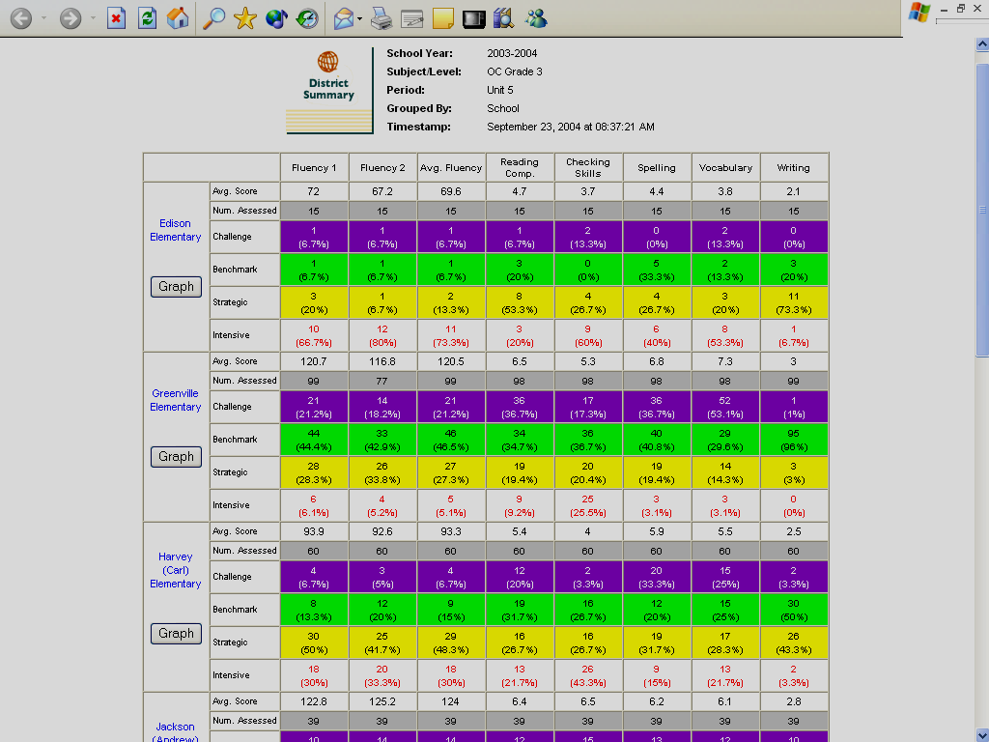

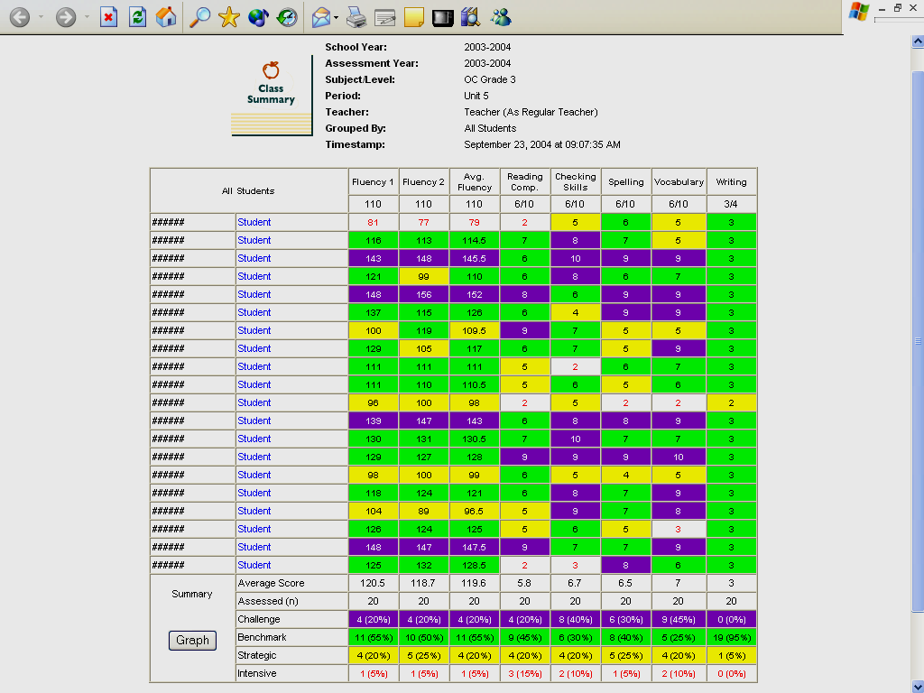

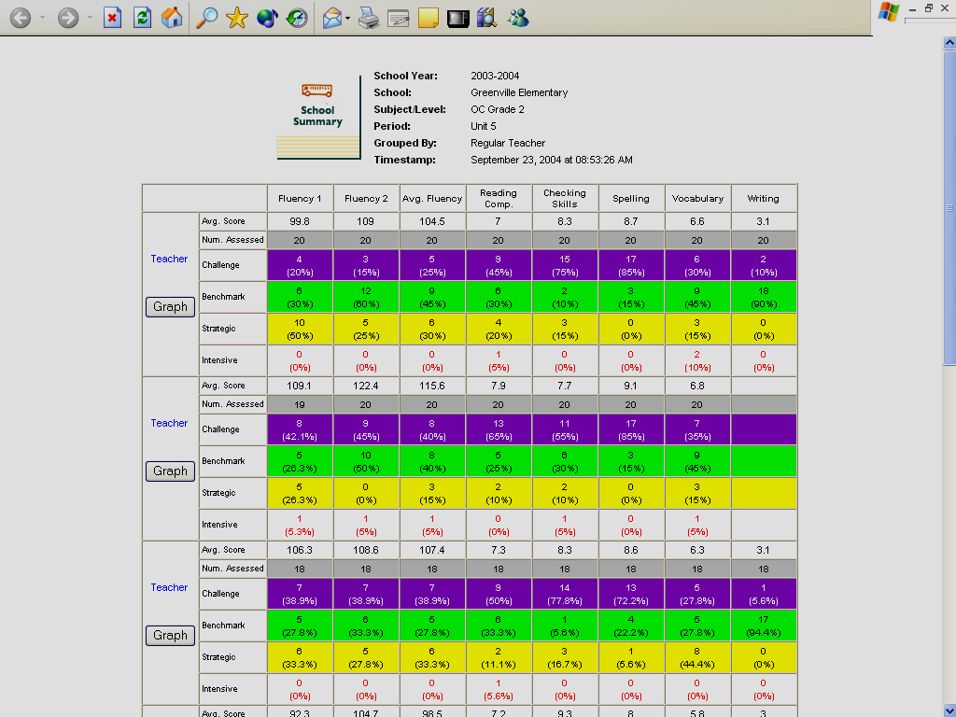

The Board requested that a special study session be scheduled to include:

- Strategies for scheduling and taking tests
- Location for testing
- Include Administration to discuss time away from instruction for students who are testing and others

PUBLIC COMMENTS/PRESENTATIONS

President Richardson asked those members of the community who wished to address the Board to step forward as he called their names.

The following individuals addressed the Board with respect to class sizes in the secondary level. They spoke about overcrowded classrooms, safety issues, and the restoration of teachers.

Meg Robinson, SAUSD Staff
Gail Burgan, SAUSD Staff
Steve Plumley, SAUSD Staff
Ernie Cannata, SAUSD Staff
Kenneth Urban, SAUSD Student
Angelita Wright, SAUSD Staff
Irma Macias, Parent

Esther Tenchil, Parent, addressed the Board concerning the placement of her daughter in kindergarten at Walker Elementary.

BOARD AND ADMINISTRATION COMMENTS:

Mr. Richardson requested to be notified if any specific instances come up at school sites in regards to class size. He further requested that District Administration keep teachers and staff updated on enrollment issues. He added that Administration keep Board updated of current enrollment. He would also like to know student projections at the beginning of school year.

Dr. Mijares stated that Dr. Bratcher and Dr. Stainer have information concerning class size that has been compiled from Principals.

Dr. Stainer provided a brief update concerning enrollment and staffing factors to date. She said that the District has staffed conservatively especially this year to allow for adherence to what the District had agreed upon and to assure that schools would not be overstaffed in light of the decreasing enrollment pattern that has been occurring over the past couple of years. She explained the procedure would have been at the start of every year. Administration would set up an extra class and make a determination to hire another teacher if the class fills. She said that because the District is working with budget constraints that is no longer the practice. She then explained the current practice. As students enter school and classes are over in numbers, then Administration and principals look at pattern and decide where classes will be set up so that schools avoid opening too many new classes with subs. She said that now that enrollment has been confirmed, the District is able to respond and recommendations have been made for additional teachers. She then reviewed staffing ratios in the elementary level.

Mr. Richardson requested that the District keep Board apprised of increasing student numbers and projections. Dr. Bratcher was then called upon.

Dr. Bratcher then discussed current staffing in the intermediate and high schools. He reiterated that the District staffed conservatively to align to the District’s finance plan. He stated that the four comprehensive high schools have come in over projection. He then reviewed the following:

Schools Projected No. Currently enrolled Current Staffing
of Students 33.5 to 1

Century 2450 2517 78
Saddleback 3081 3160 99
Santa Ana 3781 3990 125
Valley 2910 2936 92
Chavez 300 217 13
Middle College 300 274 13
Mountain View 250 254 11
_____________
Total= 834

Dr. Bratcher said that following a visit to Saddleback today, he is recommending an additional foreign language teacher. He then reviewed the additional teacher restoration and growth at each comprehensive high school:

High Schools Restorations Growth

Santa Ana 3 2
Saddleback 4 6
Valley 6 5
Century 2 4

Mr. Palacio inquired about the total number of teachers at Santa Ana High School in comparison to the other comprehensive high schools, which he said does not add up. Mr. Palacio said that Santa Ana High is feeling the brunt of the growth of students, but is receiving substantially less amount of teachers.

Dr. Stabler provided a response. He said that there are two separate calculations involved. The first one, you reduce the staffing ratio from 35.1 to 33.5, which took in the entire population. The second calculation is for growth, you divide 33.5 into the number of additional students, which equals the additional number of teachers. He said that he would check the numbers for the other sites.

Mr. Tinajero stated that there is a concern for all overcrowded classrooms. He visited Saddleback High School’s foreign language classes. He said that the ELD 4 class that should be 20:1 has 20 freshman and 20 sophomores. He asked that this be remedied as soon as possible. In Science classes, there is not enough room for students to take that class. He stated that perhaps Board must look at the graduation requirements this year.

Dr. Bratcher stated that this is the first time for the science requirements. He said that underclassmen from taking science because seniors must take the course. He said that when the other schools built there would be more room.

Mrs. Avila asked the following questions: Is this year more unusual than years past in terms of class size. Dr. Stabler responded that this is always an issue at the beginning of each school year until classes can be balanced out. He said that this year it is taking a little longer with the issue at hand in being more conservative.

Mrs. Avila asked if due to the budget reductions and the reduction of teaching positions, if it made the problem more serious. Dr. Stabler responded affirmatively. He said when the multi-year financial plan was discussed last year, staffing at a higher ratio and raised classroom sizes was discussed in order to come up with the $29.8 million prior to the salary agreement. She said that perhaps this communication did not reach all teachers.

Dr. Mijares stated that the Administration, Board, and he support teachers and their spirit to lower class size for all concerned. He reiterated that this district was affected significantly when our base revenue limit was reduced midyear. He reviewed the following:

- The state was unable to fund the promised COLA
- Employees made the concession of two furlough days and a 3% cut in salary
- 2006-07 – Will receive a minimum of 9.11% pay raise (ends furlough days and 3% cut for teachers)

Dr. Mijares said, “If you think the water is hot now, it will be scalding if Board cannot keep a commitment of the 9.11% salary restoration in 2006-07.” He explained how we arrived at a 700 projection. He said that the District was able to keep music teachers, nurses, and many Campus Safety Officers. He said that every teacher that Board returns to duty is a salary position that must be paid until the end of the year and historically in December schools drop enrollment. If we do not handle this systematically, the District will not make it.

Mrs. Avila asked if having Class Size Reduction (CSR) cause imbalance at the school sites. Dr. Mijares responded affirmatively. She then asked if it cost more to have CSR. Dr. Stabler stated that there is a slight encroachment in the 9th grade for $250,000. He stated that in 1-3 CSR when staffing at 19:1 as it increased to 20 and 20:4 it eliminated almost the total encroachment to take advantage of all dollars.

Mrs. Avila stated that she would like Administration to compile a report showing costs if there were no Class Size Reduction.

Mrs. Avila stated that she would like specific information placed on the Agenda for the next Board meeting concerning class size and enrollment.

Dr. Yamagata-Noji asked for an assessment of science labs and student capacity in those classes. A concern is that grades will be coming out in two weeks.

Mr. Richardson requested a report to the Board at the end of the week concerning class size/enrollment.

MEETING RECESSED AND RECONVENED

At 9:10 p.m., the Regular meeting was recessed to allow members of the audience to exit. The meeting was reconvened at 9:45 p.m.

APPROVAL OF CONSENT CALENDAR

The following item was removed from the Consent Calendar for discussion and separate action: Approval of Contract for Head Start Funding for 2004-05 Program Year.

It was moved by Dr. Yamagata-Noji, seconded by Mr. Palacio, and carried 5-0, to approve the remainder of the Consent Calendar as presented.

The following gifts were accepted subject to the condition that the District does not guarantee maintenance of the items or expenditure of District funds for their continued use.

Gifts Donors
Garfield Elementary National Council of Teachers
$5,000 for tutoring, instructional of Mathematics
supplies, and equipment Reston, VA

Hoover Elementary Target*
$156 for field trips Mr. Gregg Steinhuf
Minneapolis, MN

Santiago Elementary General Mills
$406 for instructional supplies Box Tops for Education Program
Lake Lillian, MN

Santiago Elementary Mr. Alan Wood
$295 for instructional supplies Orange

Santiago Elementary Washington Mutual Bank*
$1,811 for instructional supplies Mr. Roy Kaplan
Princeton, NJ
Lathrop Intermediate Mr. Jim Messina
Photography Tripod Buena Park

McFadden Intermediate Santa Ana Education Foundation
600 Webster Dictionaries Ms. Bernedette Medrano
Santa Ana

District Office Sterling Collision Center, LLC
$2,000 for spirit pack Mr. Joseph Kazemi, President

Approval of purchase orders issued August 25, 2004 through September 14, 2004, to purchase materials, supplies, etc., with funds previously approved.

Approval of warrant listings prepared September 1 through September 15, 2004, to pay budgeted District financial obligations.

Awards Vendor Amount
Contract for Upgraded Cingular $34,800
Cellular Phones and Service

Authorization to dispose obsolete textbooks, pursuant to Education Code Sections 39520 and 39521, Board Policy and Administrative Regulation 3270.

Approval of submission of English Language Acquisition Program (ELAP) Application for funding to the California Department of Education for the fiscal year 2004-05.

Approval to continue Memorandum of Understanding (MOU) between Santa Ana Unified School District and Orange County Department of Education/Community Services Grant Program (GSGP) for the 2004-05 School Year.

Ratification of submission of application to Orange County Head Start for additional funds for Cost of Living Adjustment for the2004-05 program year.

Approval of consultant services with the Orange County Council, Learning for Life Program at 17 elementary schools for year 2004-05.

Approval of the recommendation of the Expulsion Readmission Panel to readmit students with ID #’s 118051, 115844, 121271, 126422, 195710, 118649, 137671, and 120859 to District schools for the fall semester of the 2004-05 school year.

Approve the recommendations for the administrative hearing panels to expel the students for the recommended terms and with the recommended remediation conditions.

138957 – Lathrop Intermediate
for violation of Section (g), that the Board expel him from the schools of the District and that he may apply for readmission on or after September 28, 2005.

139490
for violation of Section (g), that the Board expel him from the schools of the District for the balance of the fall semester, 2004-05 school year, and that the expulsion order be suspended until January 15, 2-05, and that he be permitted to return to a District school/program on a probationary status.

Approval of Extended Field Trips:

Franklin Elementary School
Cedar Crest Science Camp
Running Springs, California
September 27 - October 1, 2004 (Monday-Friday)

APPROVAL OF CONTRACT FOR HEAD START FUNDING FOR 2004-05 PROGRAM YEAR

Mrs. Avila stated the reason for casting a dissenting vote is that she believes the Santa Ana Unified School District should be a K-12 district.

It was moved by Dr. Yamagata-Noji, seconded by Mr. Palacio, and carried 4-1, Mrs. Avila dissenting, to approve the contract for Head Start funding for the 2004-05 program year.

ADOPTION OF RESOLUTION NO. 04/05-2578 – CERTIFICATION OF INFORMATION RELATING TO PARTICIPATION IN THE 2004-05 CLASS SIZE REDUCTION (CSR) OPERATIONS FUNDING PROGRAM

It was moved by Mr. Palacio, seconded by Mrs. Avila, and carried 5-0, to adopt Resolution No. 04/05-2578 – certification of information relating to participation in 2004-05 Class Size Reduction Operations Funding program.

A copy of the resolution is attached to the Minutes of the meeting.

ADOPTION OF RESOLUTION NO. 04/05-2579 – DISTRICT’S APPROPRIATIONS LIMITS FOR FISCAL YEARS 2003-04 AND 2004-05

It was moved by Mrs. Avila, seconded by Mr. Palacio, and carried 5-0, to adopt Resolution no. 04/05-2579 – establishing the District’s appropriations limits for fiscal years 2003-04 and 2004-05 at $293,477,849 and $300,254,746 respectively.

A copy of the resolution is attached to the Minutes of the meeting.

AUTHORIZATION TO DECLARE UNISYS AS SOLE SOURCE PROVIDER OF HARDWARE MAINTENANCE ON A-14 AND ES7000 SERVERS AT THE INFORMATION TECHNOLOGY CENTER (ITC)

It was moved by Mr. Tinajero, seconded by Dr. Yamagata-Noji, and carried 5-0, to authorize Administration to declare Unisys as the sole source provider to hardware maintenance on the A-14 and ES700 servers at the Information Technology Center (ITC).

approval of stephen c. teele, ph.d. for educational and financial review of district’s charter schools

Dr. Yamagata-Noji requested an additional report including Charter schools.

It was moved by Dr. Yamagata-Noji, seconded by Mr. Palacio to approve Dr. Stephen C. Teele for services, for the 2004-05 fiscal year.

APPROVAL OF PERSONNEL ACTION

It was moved by Mr. Tinajero, seconded by Dr. Yamagata-Noji, and carried 5-0, to approve the Personnel Calendar with modifications to pages 57 and 58.

Dr. Yamagata-Noji brought to the attention of the Board that Mr. Gary Wheaton, Director Educational Technology would be retiring. The Board congratulated Mr. Wheaton.

A copy of the Personnel Calendar is attached to the Minutes of this meeting.

DISCUSSION ITEMS:

DISCUSSION OF MASTER PROGRAM BUDGET (MPB) and Status of Historical Expenditure Report for the School Building Program

Mrs. Brown introduced the item. She then introduced Mr. Jay Davison, Capital Program Management who provided information on status and funding, and Ms. Brown provided information on options and future tasks.

Mr. Davidson stated that when he previously presented information to the Board there were ten State funded modernization projects that had approved funding. He reviewed the recapturing of monies and matching funds. He then said that the District has bid all 10 projects and awarded Fremont and Sierra, which will come to the Board at the next Board meeting. He announced that the District had worked their way through the ten projects and was moving on to the next group. In addition, the District is moving forward with the Mountain View High School project as was approved, at the previous meeting. He then referred to the MPB report. There is a new column on (tab 11) under “funding” showing $600,000 on the funding side for Heroes, high performing school. Mr. Davidson stated that the new balance of $24,472,422 is the amount District has to work with. He then called upon Ms. Brown.

Ms. Brown provided the future funding issues as follows:
- Central Park CFD) - $5,500,000
- Tustin Base Redevelopment COP - $3,000,000
- Portable Return COP - $7,700,000
- El Sol - $2,878,498
- Totaling $19,078,498

Mr. Palacio requested a more detailed breakdown of the $19 million.

Ms. Brown then reviewed the projects for consideration and several options for future direction. She then provided next steps and project status as follows:

Otsuka
- Eminent Domain Trial scheduled for early December (cannot move forward until after trial)
- All State funding and approvals secured
- Decision to construct at completion of trial in December/January.

Heroes

- Project in back-check at DSA (expect stamp October 2004)
- Awaiting State agency approvals and funding
- Maximum funding if District submits to OPSC in November for January 2005 funding from the State Allocation Board
- October/November decision to submit to State

Valley Modernization
- Project in back-check at DSA (expect stamp October 5, 2004)
- Awaiting State agency approval and funding
- Maximum funding if District submits to OPSC in November for January 2005 funding from the State Allocation Board
- October/November decision to submit to State

New Griset
- Sale of Farmer’s site in escrow (estimated close Nov./Dec.)
- Negotiations with County of Orange for new site continuing
- Project in schematic design
- Decision to move forward with acquisition January 2005

Status of Historic Expenditures Earlier Projects
The MPB includes cash on hand as of September 30, 2003 and future revenues:
- Budgets for a possible 32 priority projects were calculated and updated
- Projects that ranked lower in priority had their budgets reduced t expenditures incurred
- Projects that have completed construction are in the process of having their budgets and purchase orders reduced to expenditures incurred
- Expenditures for 32 projects are accounted for in the MPB

All expenditures prior to September 30, 2003, are in the process of reconciliation

Why do this reconciliation?
- Sound accounting practices
- Board of Education request
- Bond Oversight Committee request
- CPM will complete the reconciliation as additional data downloads from the District’s accounting systems, past and present, are generated.

Discussion ensued concerning the greatest need for schools, the placement of children, and ADA.

Ms. Brown said that CBEDS results would come in on October 6. She will register those numbers in the GIS and report demographics to the Board.

Mr. Palacio stated that Administration must think more in terms of ADA and a financial model.

Mrs. Avila expressed the need to modernize Valley as the other two high schools are coming soon. She asked that Valley be included in demographic study.

Dr. Noji asked that District do some serious planning regarding Valley. She posed the question, how much modernization is necessary and how big do we want the school?

Mr. Richardson requested a Post-Occupancy Evaluation to be completed on Washington and other schools as they are modernized to help with future construction.

The Board thanked Ms. Brown and Mr. Davidson for an informative presentation.

Discussion and Approval of Easement Agreement for Supplemental Vehicular and Pedestrian Access to the Taft School Site

This item was removed from the Agenda and will be returned to a future Board meeting.

BOARD AND STAFF REPORTS/ACTIVITIES - REPORTS ON VISITS TO SCHOOLS, CONFERENCES ATTENDED, OR MEETINGS SCHEDULED
Mr. Tinajero:
- He congratulated Saddleback High School for their win against Valley High School last week.
- Announced the next football game Saddleback vs. Santa Ana High School on Friday, October 1, at the Bowl.
- Santa Ana High student Robert Vargas won the gold medal in his weight class at the Pan American games. Mr. Tinajero asked for financial assistance as the student continues his quest to the Olympic team, he must travel to North Vietnam.
Mrs. Avila:
- Commended the Folklorico dancers at the Washington Elementary Open House for doing a wonderful job.
- Requested a Moment of Silence for the Santa Ana High School student who passed away last week.
Dr. Yamagata-Noji:
- Tour of Construction began at Manuel Esqueda Elementary then moved on to Segerstrom High School, and Godinez Fundamental High School. Was very informative, interesting to see the phases of the project, and fun.
- Commended the Wal-Mart volunteers Rebuilding Together at Spurgeon Intermediate for their contributions to the school. She said that they constructed new platforms in the back of the school.
- Attended the GEAR UP Partnership event at McFadden, which was a very successful.
- Attended the Washington Elementary school opening/open house.
Mr. Richardson:
- Echoed Dr. Yamagata-Noji’s comments.
- At the Washington Open House, the performances were great. He saluted Mr. Duran, Principal; Mr. Samuels, Choir teacher; Folklorico dancers; and students.
- Enjoyed the construction tours, total student seating will be 6500.

Mr. Richardson called for a Moment of Silence in respect to student Noe DeSantiago, from Santa Ana High School.

ADJOURNMENT

There being no further business to come before the Board, the Regular Meeting was adjourned at 10:40 p.m.

FUTURE MEETING

The next regularly scheduled meeting of the Board of Education will be held on Tuesday, October 12, 2004, at 6:00 p.m.

ATTEST: ____________________________
Al Mijares, Ph.D.
Secretary
Santa Ana Board of Education

