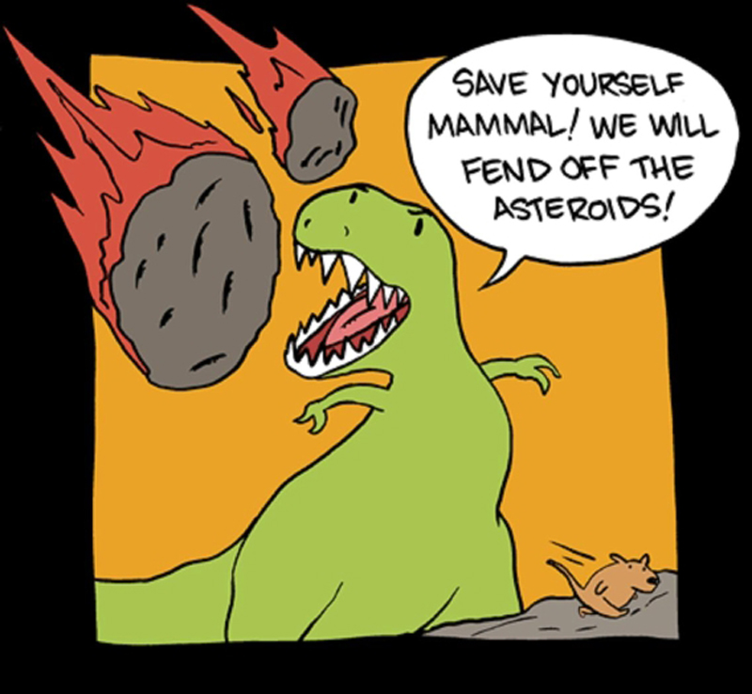 | Mr. Morris’s 8th grade  Integrated Science Class  McFadden Intermediate, Room 19  Phone Number: (714) 479-9000  Email: thomas.morrisiv@sausdlearns.net  Twitter: @morris_science  Instagram: morris_science  Tutoring 7:30-8:00, Daily | 
Hello Everyone! I am so excited to start off the 2016-2017 school year as your science teacher! This year brings a number of changes to the science curriculum. We are moving forward with the integrated model of the Next Generation Science Standards. This means that there are a mix of topics to be uncovered and practiced through labs, projects, and a number of other learning models. Our year will center around the theme of asteroid impacts and their effects on Earth and human history. My main objectives this year are to prepare you for advanced science in high school as well as instill a love for inquiry and discovery.

Class Expectations:
- Always bring materials (agenda, Journal, pencil, iPad, etc.) to class.
- Everyone gives their best effort, everyday.
- Stay on task and support the learning of others.
- Follow directions the first time they are given.
- If you have a question, ASK!

Mandatory Tutoring and Quiz Retake Policy
If students score below a 70% on a quiz, they are REQUIRED to attend a tutoring session in order to retake the quiz. The tutoring session is approximately 20 minutes, followed by 15 minutes to complete the quiz. An option will also be available to watch a video online instead of attending the tutoring session. The quiz can then be completed before or after school.

Absence Policy:
It is very difficult to make up work when absent, so try very hard to be at school! If absent, it is the students’ responsibility to make up any work or test missed. If they do not make up the work or test they will receive a ZERO on that assignment.
- Tests and Quizzes that were missed will be made up upon returning to class.
- Labs and in class assignments can sometimes be made up at nutrition or before school, but expect an alternative assignment if the materials are already put away.
- Students should ask a buddy what they missed and to copy the missed notes.
- Please check the absence box for missed handouts.

Bathroom Breaks:
It is the student’s responsibility to use the bathroom during passing periods or lunch. Use your restroom passes wisely, the ones you are issued are meant to last the entire semester. Students without passes will not be allowed to use the restroom. If you have a medical need, please have your parents contact the school nurse.

Grades:
Grades will be based on your accumulation of points (tests, quizzes, homework, projects, labs, participation, etc.) and will be figured using the following standard percentage scale:
- A 100-90%
- B 89-80%
- C 79-70%
- D 69-60%
- F 59-0%

Managing Technology:
We will be using iPads DAILY. Make sure your device is charged every day. Expectations for using internet enabled devices in class include:

- Students WILL use iPads in class when instructed to do so.
- They MAY NOT use personal phones or at any time be using their device for texting, gaming, listening to music, social media or taking pictures unrelated to the assignment.

Phones must also be turned off and put away, as incoming phone calls or texts are not permitted. Failure to follow these policies will produce consequences up to and including loss of device.

If a student has a device out in class when it is not permitted, the device will be confiscated and a parent will need to pick it up.

Web Page/Social Media:
I will be using both Instagram and Twitter to post our daily agenda, objective and homework. These are accessible without an account through my teacher page at: http://bit.ly/morris_science2016. If a student is absent, they can check one of the feeds and may be able to complete the assignment on their own.

I will also use these apps to answer any questions that students or parents may have about class or an assignment.

Consequences:
Students who are being disruptive will face the following consequences:

1st Offense | Verbal Warning
2nd Offense  3rd Offense | 1st BLACK HOLE Consequence Card  2nd BLACK HOLE Consequence Card, Behavior Reflection, Loss of Privileges
4th Offense | Referral & Parent Contact

If detention is missed it will DOUBLE. If it is missed twice it becomes an administrative detention.

Cheating/Bullying:
Cheating and bullying are never acceptable and is not tolerated. Plagiarized work from any source will also not be accepted. I often check online to confirm whether or not students have copied a source. If students cheat or turn in plagiarized work they will receive a zero on the assignment and will also receive a referral to the office.

(do not cut out)
For the record:
Once you have finished reading over the procedures, please sign your name at the bottom of this page and also include your parent/guardian’s contact information. Please glue into your science journal, signed, by Friday Sept 2nd!

Student’s Name (Printed):________________________________________________

Student’s Signature:_______________________________________________

Parent/Guardian’s Name (Printed):________________________________________________

Parent/Guardian’s Signature:_______________________________________________

Parent/Guardian’s Phone # and/or email: _____________________________________________

