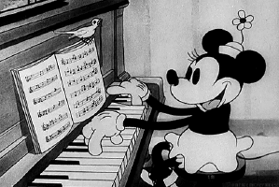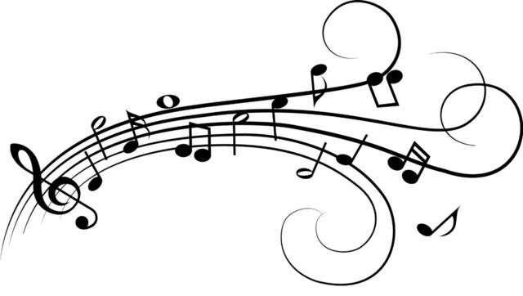

**Piano**

Where?

* Ms. Loh’s Room
* D304

Who?

* Beginning
* Intermediate
* Advanced

Why Join?

* VAPA Class
* Music Rocks!

Learn All About:

* Music Fundamentals
* Music Notation
* Musical Scales
* Piano Chords
* Various Repertoires

**Beginning Instruments**