Homework

Third graders have three main tasks for homework.

1. Reading: Your child is expected to read their leveled reading book each night at home, Monday thru Thursday. Please record how many books your child reads on their reading log. At the end of the month students can turn in a completed reading log, with a minimum of 4 books per week or the equivalent of 2.0 Accelerated reader points.
2. Math: Most nights, your child will have a math page to do in my class. Please have your child explain to you what they are learning in class. The homework assignment requires the child to practice the skill they learned that day in class. If you have any questions, please feel free to call or stop by. When we have a Math tests there is no homework for that day.
3. Science and Social Science: Later in the year your child will be responsible to complete assignments at home from the science and social science workbooks.

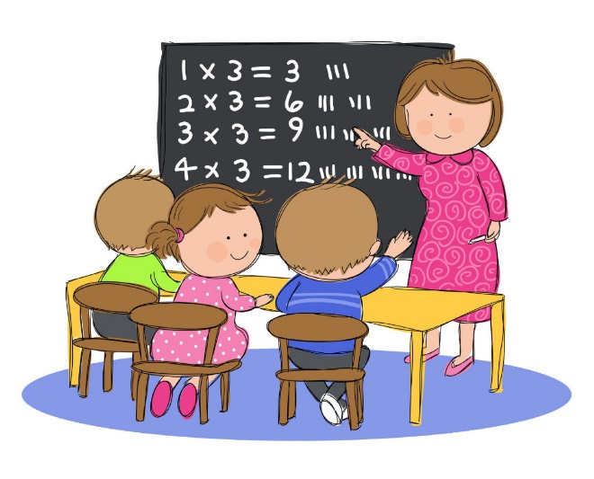

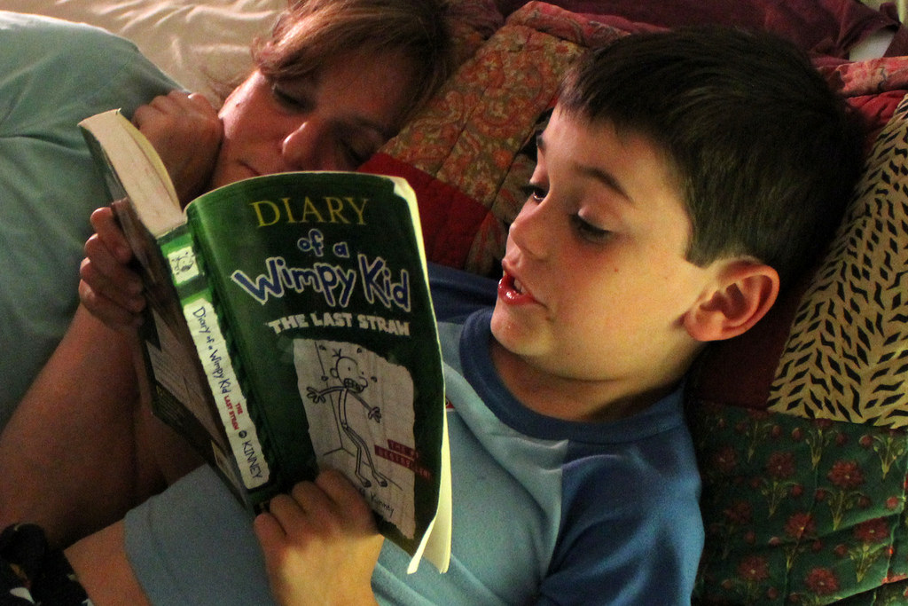

Source:

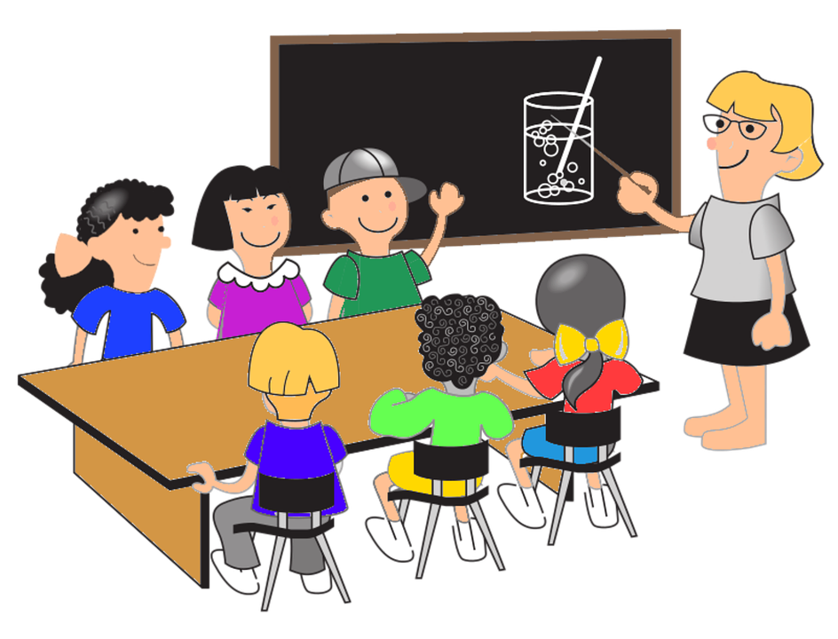

Pictures

<http://alohamindmath.com/tag/picture-books/#.V8oojJgrKhc>

<http://cliparting.com/free-classroom-clipart-8261/>

<http://alishaorganmathblog.weebly.com/>