CH 35 Lecture: America in WWII

Allies Trade Space for Time
Background: ABC-1 Agreement with Britain: “get Germany 1st” (instead of Japan) due to Hitler’s threat of over taking USSR and Britain.
-Many Americans didn’t know/understand what WWII was about.
- 1st Challenge: Prepare factories to produce all out war supplies: food, clothing, arms, machinery.
- WWII sped up assimilation of immigrants to American society.
Tmwk Ch 35
1. Pg 822 Cartoon: What is the cartoon depicting? Topic, time period, key ppl/country, geo location, Add OI.
2. Pg. 823 picture: Give two specific details how "enemy aliens" were treated.
Japanese Americans
- U.S. govt feared Japanese Americans would be spies/saboteurs, if Japan invaded U.S.
- Placed them in internment camps even though 2/3 born in U.S. - Many lost property and earnings – violation of rights.
  - 1944 Korematsu v. U.S.: Supreme Court upheld constitutionality of the Japanese relocation to internment camps = Executive Order 9066.
  - Supreme Crt Justice Hugo Black held that the need to protect against espionage or sabotage outweighed Fred Korematsu's individual rights and rights of Japanese Americans

Fred Korematsu was born in the U.S. and was a Japanese American man who decided to stay in San Leandro, California and knowingly violate Civilian Exclusion Order No. 34 of the U.S. Army. Fred Korematsu argued that the Executive Order 9066 was unconstitutional and that it violated the Fifth Amendment to the United States Constitution. He was arrested and convicted.
Justice Hugo Black: “Korematsu was not excluded from the Military Area because of hostility to him or his race. He was excluded because we are at war with the Japanese Empire, because the properly constituted military authorities feared an invasion of our West Coast and felt constrained to take proper security measures, because they decided that the military urgency of the situation demanded that all citizens of Japanese ancestry be segregated from the West Coast temporarily, and, finally, because Congress, reposing its confidence in this time of war in our military leaders — as inevitably it must — determined that they should have the power to do just this.”

- 1988: U.S. govt officially apologized - made payments of $20,000 to camp survivors.
- Early 1940's: Congress voted to end CCC (Civilian Conservation Corps), Works Progress Administration, National Youth Administration. Focus shifted from economy to war.

Building the War Machine
- War Production Board: Govt agency that regulated production and use of raw materials and fuel during WWII - prohibited nonessential production such as cars. Rationed needed items: gasoline, heating oil, metals, rubber, paper, plastics.
- Full employment and scarce consumer goods caused high inflation in 1942.
- Office of Price Administration OPA: To control prices and inflation after outbreak of WW II. Given power to place ceilings on all prices except agriculture and to ration scarce supplies of essential goods: tires, automobiles, shoes, nylon, sugar, gasoline, fuel oil, coffee, meats, processed foods.
- War Labor Board WLB: prevented work stoppages which might hinder the war effort. Made wage controls - placed ceilings on wage increases in national industries.
- 1943 Smith-Connally Anti-Strike Act: federal govt allowed to operate industries threatened by strikes that would interfere with war production. Made it a crime to strike in a govt seized corporation. Govt took over coal mines because of strikes by United Mine Workers and the railroads.

Tmwk
3. Pg 827 Two pictures: Describe how women participated in the war in the "Home Front."
Manpower and Womanpower
- Men drafted, except workers in certain important areas: industrial and agricultural.
- Women employed in non-combat duties: WAACs (army), WAVES (navy), SPARS (coast guard).
- New workers needed: Mexico provided workers in agriculture. Braceros: harvested fruit and grain. Braceros also worked in railroad industry and track maintenance.
- 6 million women worked in factories: Rosie the Riveter – 3,000 day care centers set up. At war’s end, 2/3 of women war workers left their jobs since returning soldiers needed jobs and to care for their family.
Tmwk
4. Pg 828 Map: Describe in geographic terms the migration that occurred during WWII.
5. Pg 829 picture: How did African Americans participate in the war? Were there any restrictions placed? Explain
6. Pg 830 2 pictures: Choose one picture. Explain what the ethnic group is experiencing.

Wartime Migrations
- War industries brought people to migrate to booming cities: LA, NY, Detroit, Seattle.
- FDR focused on developing the South’s economy by giving them defense contracts.
- Blacks left South for employment in the West and North. Conflict came over employment, housing, and segregated facilities.
- Fair Employment Practices Commission FEPC: required companies with govt contracts not to discriminate due to race or religion. Intended to help African Americans and other minorities obtain jobs in the homefront war industry.
"there shall be no discrimination in the employment of workers in defense industries or government because of race, creed, color, or national origin."
- Blacks were drafted - mostly to serve in non-combat units.
- Congress of Racial Equality CORE: sought to apply the principles of nonviolence as a tactic against segregation.
- Black migration effected by use of mechanical cotton picker – did the work of 50 people, so need for cheap labor in the South declined. Result: 5 million black tenant farmers and sharecroppers migrated north.
- Native Americans served in armed forces. Comanches and Navajos became “code talkers” – sent radio messages in their language; Germans and Japanese couldn’t understand.
- 1943 Zoot Suit Riots: Riots erupted in LA between white sailors & Marines and Latinos. Mexicans wearing “Zoot Suits” - attacked due to racial tensions.
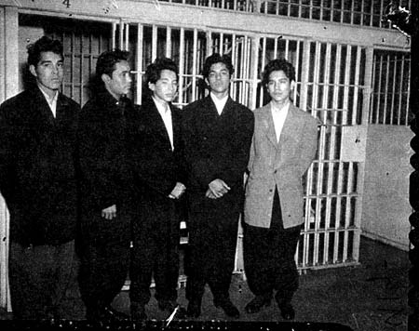

Tmwk
7. Pg 831 Graph: Describe a trend depicted in the graph: include the topic, time period, trend, ADD OI.
Financial Impact of War
- During war, gross national product (GNP) rose from $100 billion to more than $200 billion.
- Even with wage ceilings, personal income doubled due to overtime work.
- 1946: American buying pushed prices up 33% (inflation).
- WWII cost over $330 billion, 10 times the cost of WWI; National debt went up from $49 billion to $259 billion.
- Income tax was expanded and tax rates rose up to 90%.
- 2/5 of war costs paid by govt revenues, but mostly paid by borrowing money.

TMWK
8. Pg 832 Map: Describe the Bataan Death March using the map and the paragraphs.
Rising Sun in the Pacific
- Japan made successful attacks on American outposts: Guam, Wake, and Philippines.
- Took control of Malaya, where there was an important supply of rubber and tin.
- General Douglas MacArthur: American commander in Pacific Theatre: held off Japanese attack in Philippines, until combined American-Filipino army defeated April 1942, but guerrilla resistance continued.
Douglas: “I shall return.”
- Bataan Death March: 75,000 American and Filipino prisoners of war forced to march 80 miles to camps under horrible conditions - physical abuse and murder - beheadings, cutting of throats and casual shootings were common actions.
Japan’s High Tide at Midway
- Japan continued to push southward: invaded New Guinea and Solomon Islands.
- Battle of Coral Sea: 1st naval battle where fighting all done by carrier-based aircraft and neither side's ships sighted or fired directly at each other.
- June 1942 Battle of Midway: Japan attacked Midway Island (1,000 miles from Hawaiian Islands) U.S. Navy, led by Admiral Chester Nimitz and Admiral Raymond Spruance defeated Japan’s navy – all by aircraft. American codebreakers: able to determine date/location of the attack, enabling U.S. Navy to set up ambush.
TMWK
9. Pg 834 Map: What plan do you think would be the best to defeat Japan and why? Which plan did the US actually use: describe it.

American Leapfrogging Toward Tokyo
- U.S. captures Guadalcanal Island; Plus, New Guinea – led by Gen. Douglas MacArthur
- U.S. Island Hopping Strategy: Bypass heavily fortified areas, capturing islands where airfields could be set up. Possible because Allies used submarine and air attacks to blockade and isolate Japanese bases, reducing Japanese ability to resupply and reinforce.
- Battle of Philippine Sea (AKA "Great Marianas Turkey Shoot"): US won a decisive naval battle and the largest aircraft carrier battle in history.
TMWK
10. Pg 838 Map: A) Describe the D-Day plan - the strategy (also pg 840). B) Which countries remained neutral? C) Describe how the Allies advanced- red use geographic location)
Allied Halting of Hitler
- Germany had ultramodern submarines: 1942 in 10 months – 500 merchant ships damaged/destroyed by German subs.
- Late 1942, turning point of land-air war against Germany: Britain launched a thousand-plane raid on Cologne. Aug 1942 - American air force joined Britain to bomb German cities.
- German General Rommel, had driven close to the Suez Canal. British General Montgomery gave a strong attack at El Alamein with the aid of American Sherman tanks – drove the Germans back.
- Russians held Germans off at Stalingrad and Stalin regained 2/3 of the land that Germany had taken.

2nd Front: From N. Africa to Rome
- As Hitler’s armies had taken much of western USSR – they called for a 2nd front to divert German strength.
- Early 1942: FDR promised Soviets he would open a 2nd front on European continent by end of 1942. FDR couldn’t keep this promise.
- Instead of European front, attack was made in N. Africa Nov. 1942: led by American General Dwight Eisenhower – the invasion was the largest waterborne effort up to that time; German-Italian army was trapped in Tunisia and surrendered May 1943.
- FDR met Churchill to discuss stepping up the Pacific War, invade Sicily, and call for “unconditional surrender.”
- “Unconditional surrend er” was criticized for causing the enemy to fight to the very end.
- Mussolini deposed; Sicily fell to Allies; Italy surrendered unconditionally.

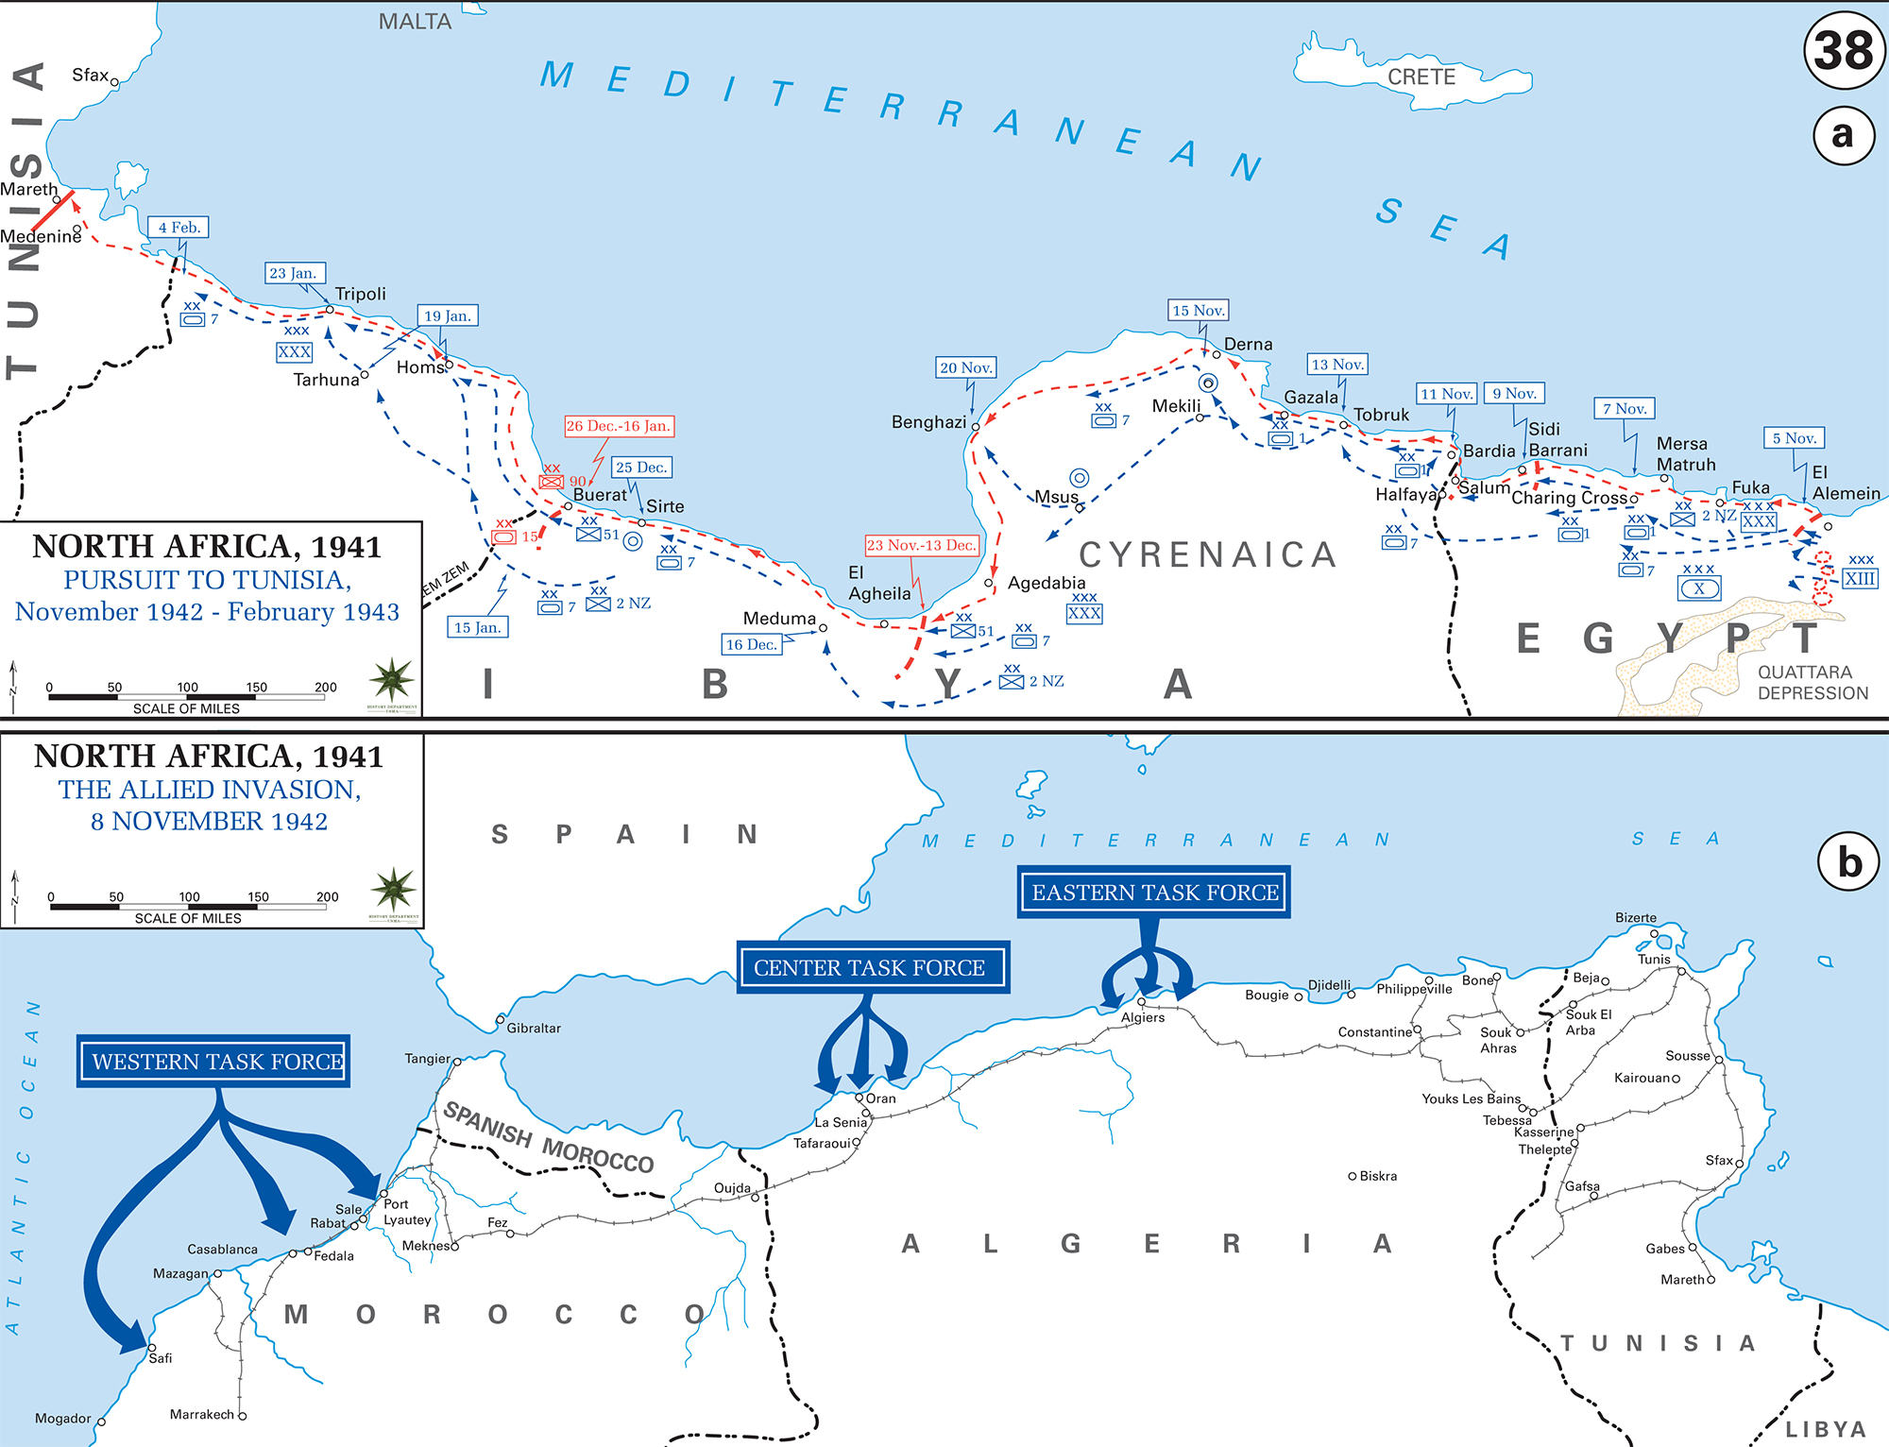

D-Day: June 6, 1944
- Teheran Conference with Big 3: Churchill, FDR, Stalin – launching Soviet attacks on Germany from the east along with Allied attack from west to open a 2nd front in Europe.
- D-Day Invasion of France: led by American General Eisenhower: assault of 2 phases: 1. air assault landing of 24,000 American, British, Canadian and Free French airborne troops shortly after midnight, 2. amphibious landing of Allied infantry and armoured divisions on coast of France. Paris liberated: Aug 1944.
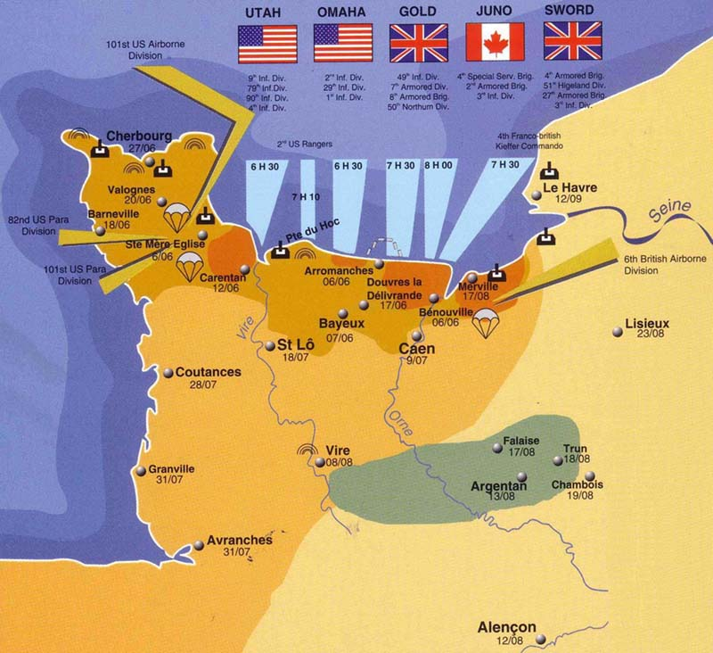

FDR: 4th Term 1944
- Republican Candidate Thomas E. Dewey: Platform of creating a new international organization to maintain peace, doing better at fighting the war,
- Democrat Candidate FDR: because of FDR’s age - lot of focus was on his VP candidate – Harry Truman. (“forgotten man of the convention” - opposed by most newspapers)

FDR Defeats Dewey
- Why did FDR defeat Dewey? Because war was going well and FDR had the experience for post war negotiations.
TMWK
11. Pg 843: What did Gen Eisenhower order German civilians to do?

Last Days of Hitler
- Major German offensive launched towards end of WWII to try to win the war.
- Densely forested Ardennes Mountains region of Belgium to capture Port of Antwerp. Germans advancement caused a “bulge” in Allied lines, hence "Battle of the Bulge."
- Eventually German advance was stopped after the 101st Airborne Division stood firm.
- Gen. Eisenhower reached the Elbe River; Allied soldier discovered horrors of Nazi concentration camps.
- April 1945: USSR fought through and reached Berlin, Germany. (FDR died April 12)
- Adolf Hitler committed suicide

Japan Dies Hard
- American subs destroyed 1,042 Japanese ships.
- Bombed Tokyo – destroying buildings and lives.
- Gen MacArthur attacked Philippines at Leyte Island. Americans fought 3 battles in this area - won all 3.
- Japan lost 60 ships and no longer a sea power.
- Kamikaze pilots committed suicide crashing into Allied ships.

Post War Discussions
- July 16 - Aug 2, 1945: Potsdam Conference: Big 3 met (Churchill/Atlee, Stalin, Truman) to decide how to administer punishment to defeated Nazi Germany, who agreed to unconditional surrender 9 weeks earlier, on May 8 (V-E Day). Goals of conference included a call to Japan to surrender, establishment of post-war order, peace treaties issues, and countering the effects of war.

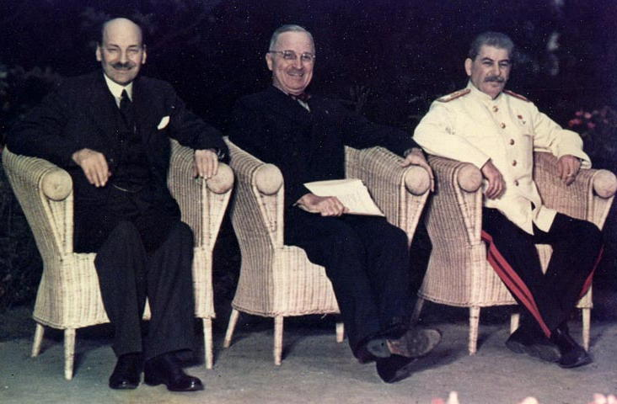
Clement Atlee Harry Truman Joseph Stalin

Why Drop the Bomb?:
-Stop an invasion of the U.S.
-Get an unconditional surrender by Japan
-Show superiority over Soviet Union in weapons
-End war quickly to save American lives
-Why not "Death Camps?" Military supplies needed elsewhere

Atomic Bombs
- Now Japan is left: Secret Manhattan Project (Albert Einstein) for development of atomic bomb.
- Aug. 6, 1945 – bomb dropped on Hiroshima. Japan refused to surrender.
- Aug. 9 – 2nd bomb dropped on Nagasaki. Japan surrenders.

